**VERZEO**

**MAJOR PROJECT**

* **Project Name:**

Cyber Security November Major Project

Venu Reddy K S

[venureddyks@gmail.com](mailto:venureddyks@gmail.com)

**Perform Scanning module by using Nmap tool (Download from internet) and scan kalilinux and Windows 7 machine and find open/closed ports and services running on machine.**

**Hacker Machine: Windows 10**

**Victim machine: kali Linux and Windows 7**

* Download nmap tool from internet from the given link below.

https://nmap.org/download.html

* Install nmap in your system
* After installing nmap will look like

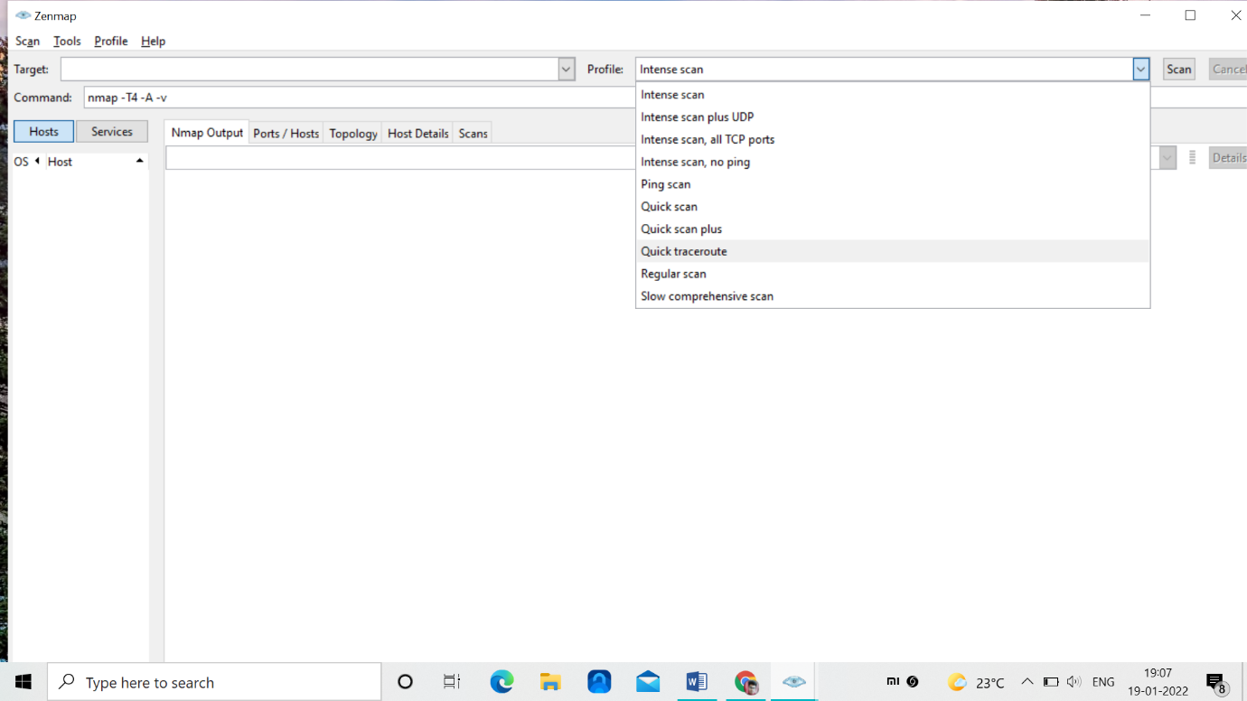

* Here we have type of scans that could be performed on a target
* nmap can be used in two ways

-> diretly through nmap

-> using it in command line (where particular

commands will be used)

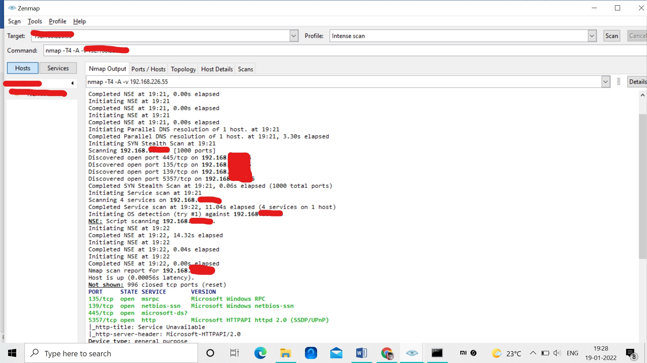

* Here we will get the information of all the open ports in the windows victim machine by their ip address
* It will show the open TCP ports

135,139,445,5357

* It will also shows the services in the victim machine like msrpc, netbios-ssn Microsoft-ds?,http

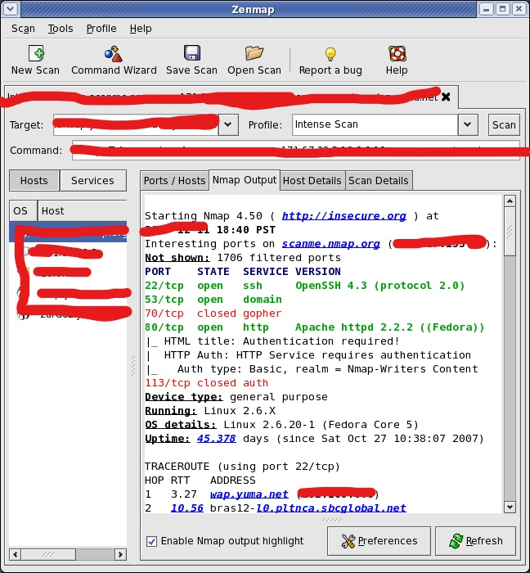

* Here the open ports are 22,53,80
* The closed port is 70
* Services are ssh, domain, http

We can scan nmap using command line and some of the commands are note below

**Basic Scanning Commands**

| **Goal** | **Command** | **Example** |
| --- | --- | --- |
| Scan a Single Target | nmap [target] | nmap 192.168.0.1 |
| Scan Multiple Targets | nmap [target1, target2, etc | nmap 192.168.0.1 192.168.0.2 |
| Scan a Range of Hosts | nmap [range of ip addresses] | nmap 192.168.0.1-10 |
| Scan an Entire Subnet | nmap [ip address/cdir] | nmap 192.168.0.1/24 |
| Scan Random Hosts | nmap -iR [number] | nmap -iR 0 |
| Excluding Targets from a Scan | nmap [targets] – exclude [targets] | nmap 192.168.0.1/24 –exclude 192.168.0.100, 192.168.0.200 |
| Excluding Targets Using a List | nmap [targets] – excludefile [list.txt] | nmap 192.168.0.1/24 –excludefile notargets.txt |
| Perform an Aggressive Scan | nmap -A [target] | nmap -A 192.168.0.1 |

| **Goal** | **Command** | **Example** |
| --- | --- | --- |
| Perform a Ping Only Scan | nmap -sP [target] | nmap -sP 192.168.0.1 |
| Don’t Ping | nmap -PN [target] | nmap -PN 192.168.0.1 |
| TCP SYN Ping | nmap -PS [target] | nmap -PS 192.168.0.1 |
| TCP ACK Ping | nmap -PA [target] | nmap -PA 192.168.0.1 |
| UDP Ping | nmap -PU [target] | nmap -PU 192.168.0.1 |
| SCTP INIT Ping | nmap -PY [target] | nmap -PY 192.168.0.1 |
| ICMP Echo Ping | nmap -PE [target] | nmap -PE 192.168.0.1 |
| ICMP Timestamp Ping | nmap -PP [target] | nmap -PP 192.168.0.1 |
| CMP Address Mask Ping | nmap -PM [target] | nmap -PM 192.168.0.1 |
| IP Protocol Ping | nmap -PO [target] | nmap -PO 192.168.0.1 |

**How to protect against nmap scans?**

We need to enable filters 7000 to7004 and 7016

These filters will ignore the following types of traffic:

* Blocked or trusted by a traffic management.
* Trusted flow due to trust as in action.
* Blocked or trusted by IP reputation.
* Matches an inspection-bypass rule.

**Test the System Security by using metasploit Tool from kali linux and hack the windows 7 / win dows10. Execute the commands to get the keystrokes / screenshots / Webcam and etc., Write a report on vulnerability issue along with screenshots how you performed and suggest th security patch to avoid these type of attacks**

**Hacker Machine : Kali Linux**

**Victim machine : Windows XP / Windows 7**

Payload: windows/meterpreter/reverse_tcp(trojan)

Attack type: Escalating control over victim machine

Payload injection: via link(on click starts to download)

Victim Machine:Windows7

Attacker Machine: KaliLinux

* Using the nmap tool scanned the victim(windows10) and got some open ports “—badsum” used was necessary otherwise it showed all ports filtered

//unfortunately the windows 10 was able to detect the payload and chrome detected it quickly

But exploiting worked for windows 10 via ssh tunel and once all antivirus was disabled meterpreter trojan could be used.

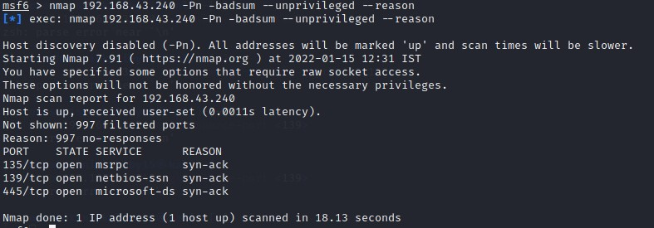

* Scanning particular port(stealth scanning “-sS”)

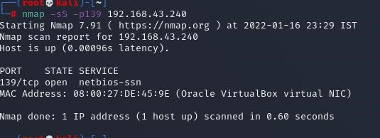

* Creating the payload:

Created a trojan as payload using msfvenom, used meterpreter as it escalates the privilages of getting full control of victim machine. Also encoding the payload 14 times with 32 bit encoder

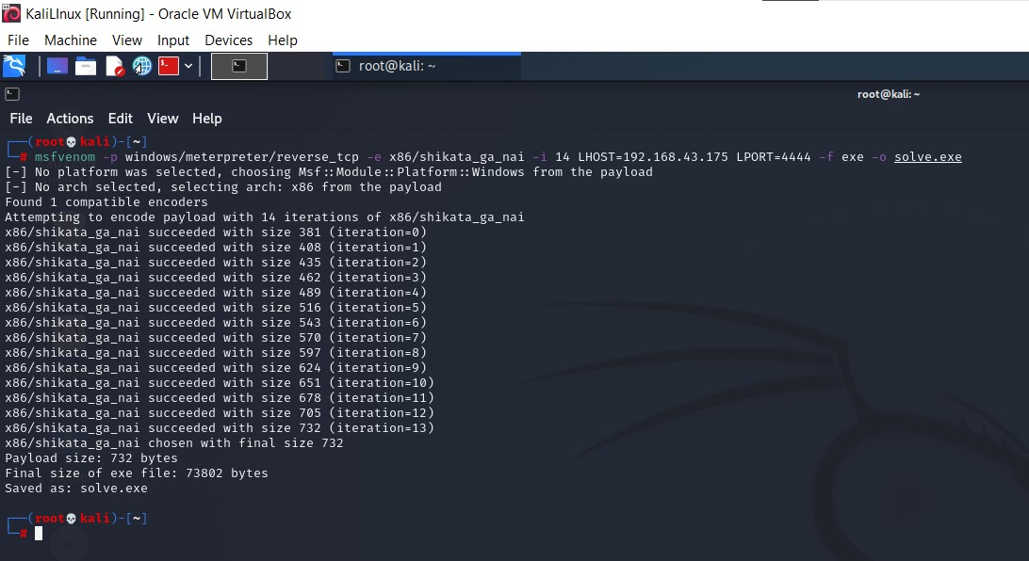

* Uploading the payload to apache server in kali linux and copying the link and adding suffix /”payload filename” to the copied link and start the apache2 service on kali linux and adding adding prefix as http:// iff the copied link is not in http format.

This new modified link is sent to victim machine via gmail(for example) if the victim clicks this link the it automatically downloads the payload via that link from apache server. By encoding the payload the antivirus was unable to detect the virus file

# ➢ Used multi handler exploit via Metasploit

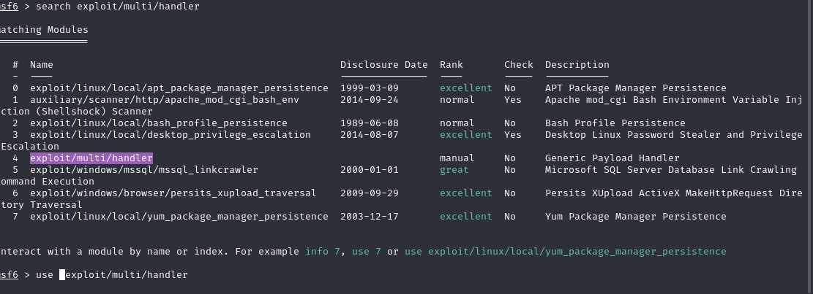

* Setting up the Metasploit for that particular payload(metrepreter,reverse_tcp)
* Setting the lhost and lport
* Checking whether the settings are correct
* Turn off the apache2 service
* Running the exploit in background using the exploit command with appropriate options
* Waiting for the victim to run the payload that was downloaded on victim machine
* Victim runs the file but there is no action seen by victim on victim machine

As soon the payload runs on victim machine a session is created and we can use that session to get the full control over victim machine and can take screen shots,traverse trouh the entire file/directories download or delete or make modification in victims machine .Also can get keystrokes i.e; whatever the victim is typing on a platform it is got traced out and we can see those key strokes in kali linux

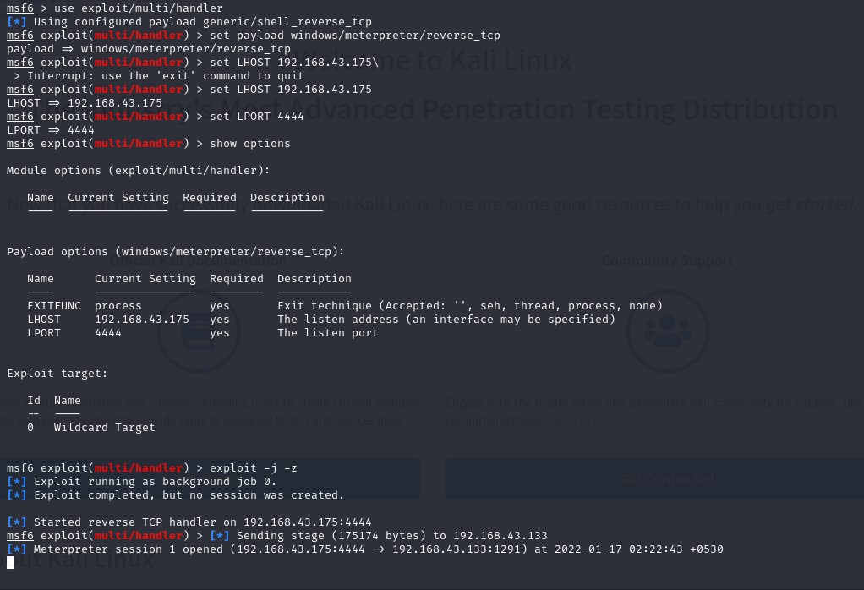

* Session was created

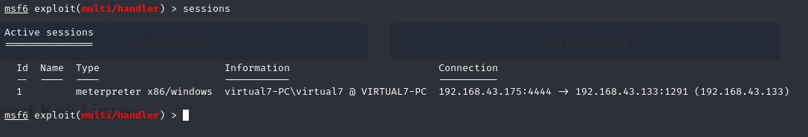

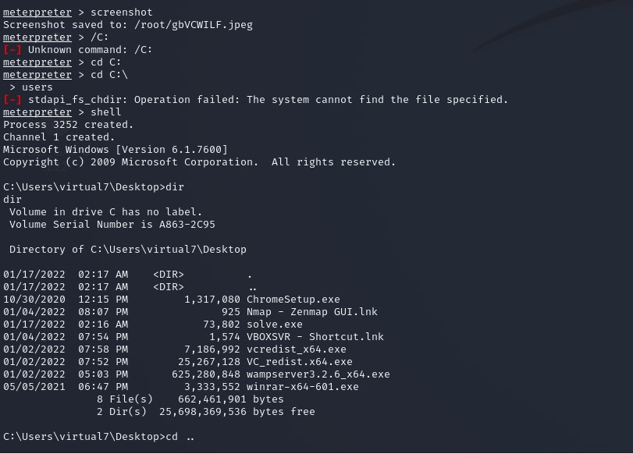

Screen shot was taken ,system configuration was seen , traversed trough directories listed all files directory had

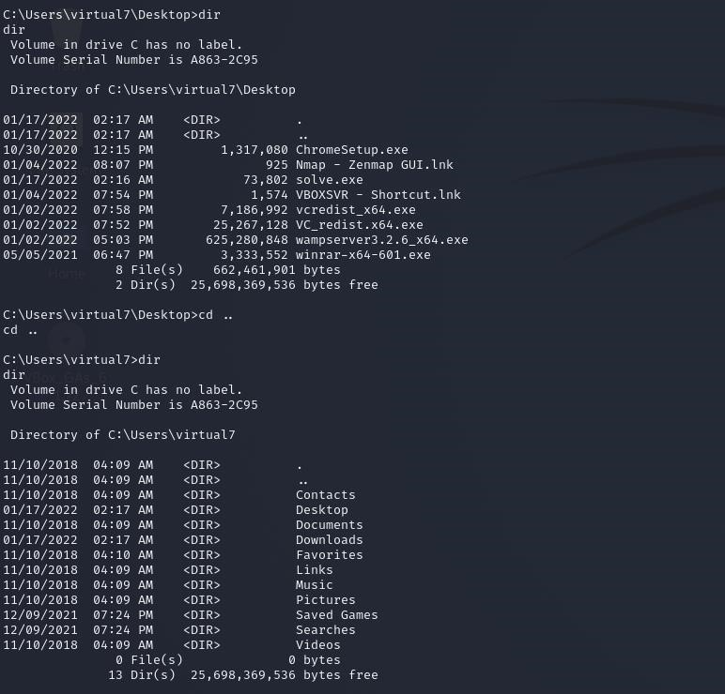

# Traveling through directories files and desktop

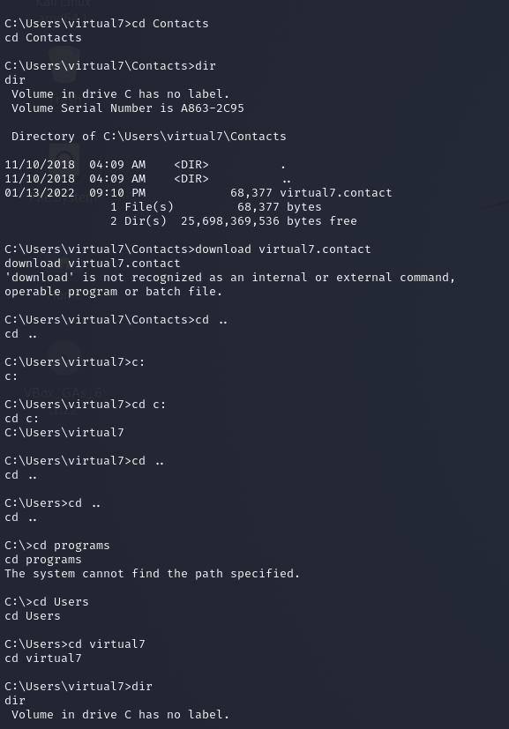

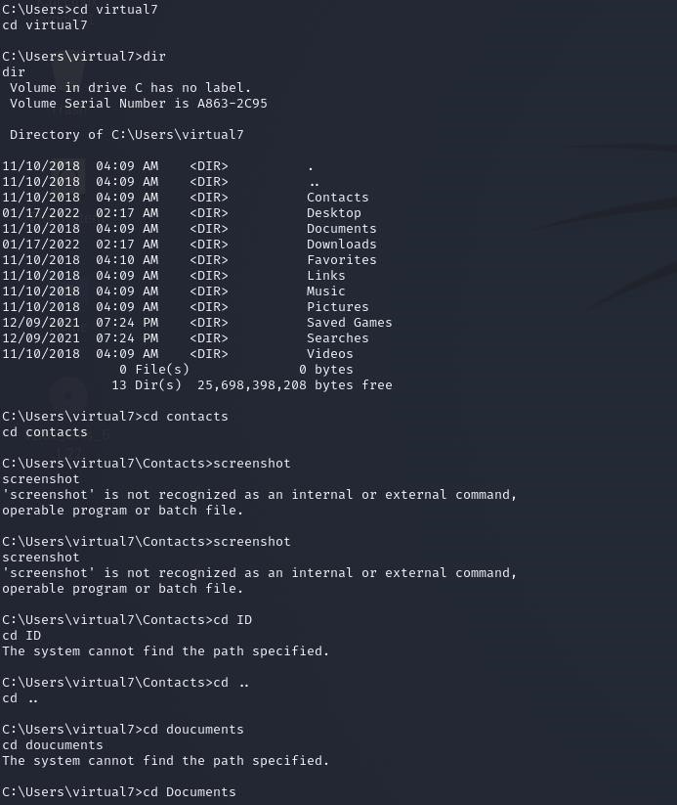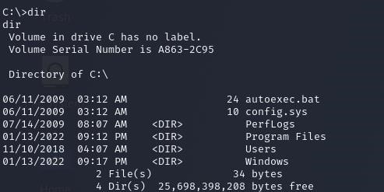

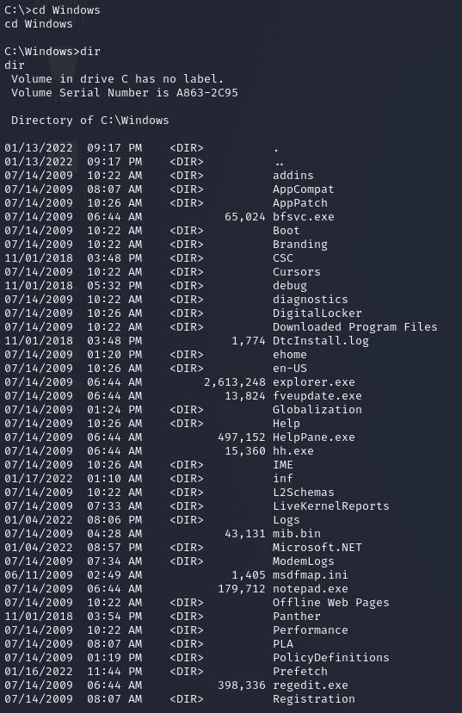

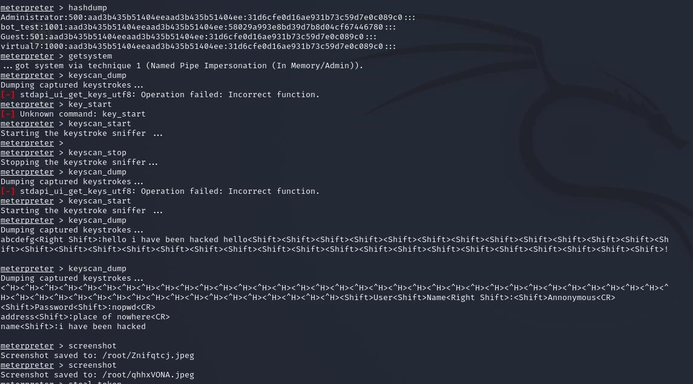

* Got administrative information interms of hash
* Got keyStrokes by scanning

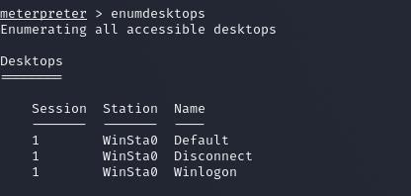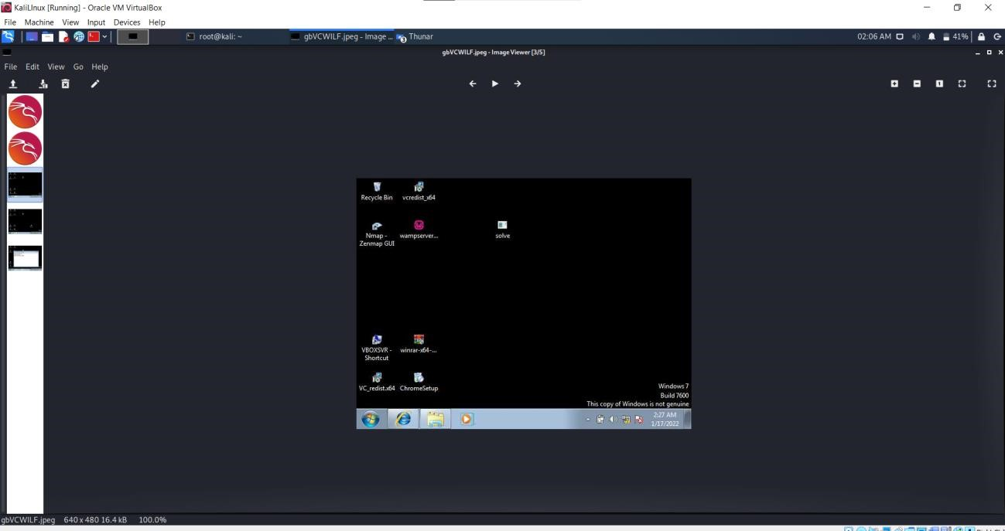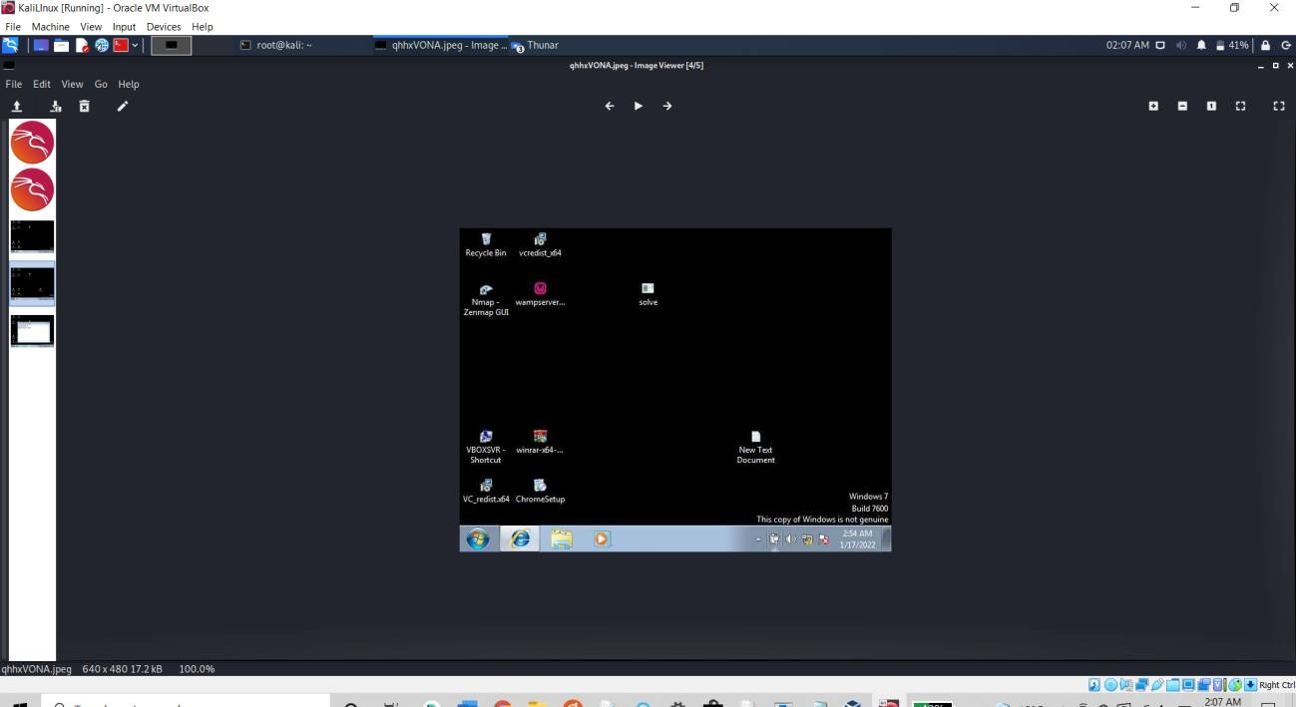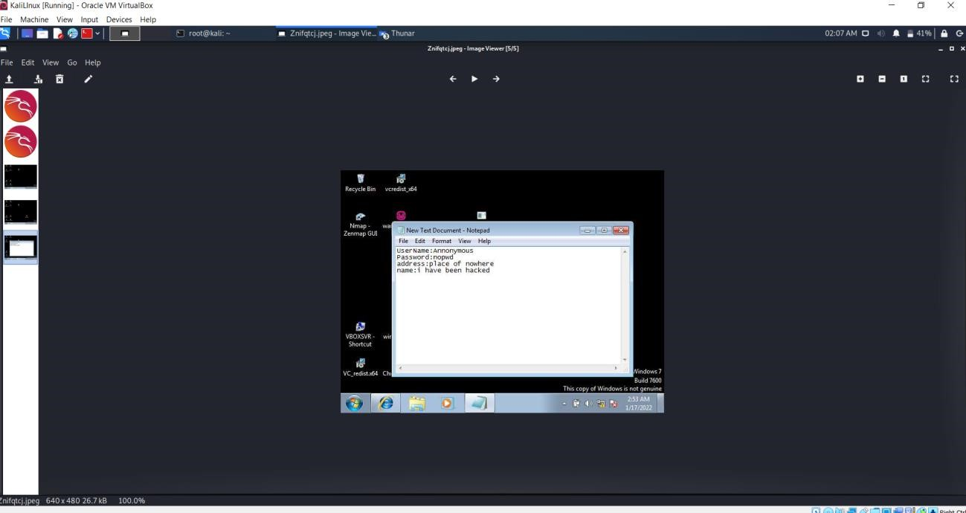

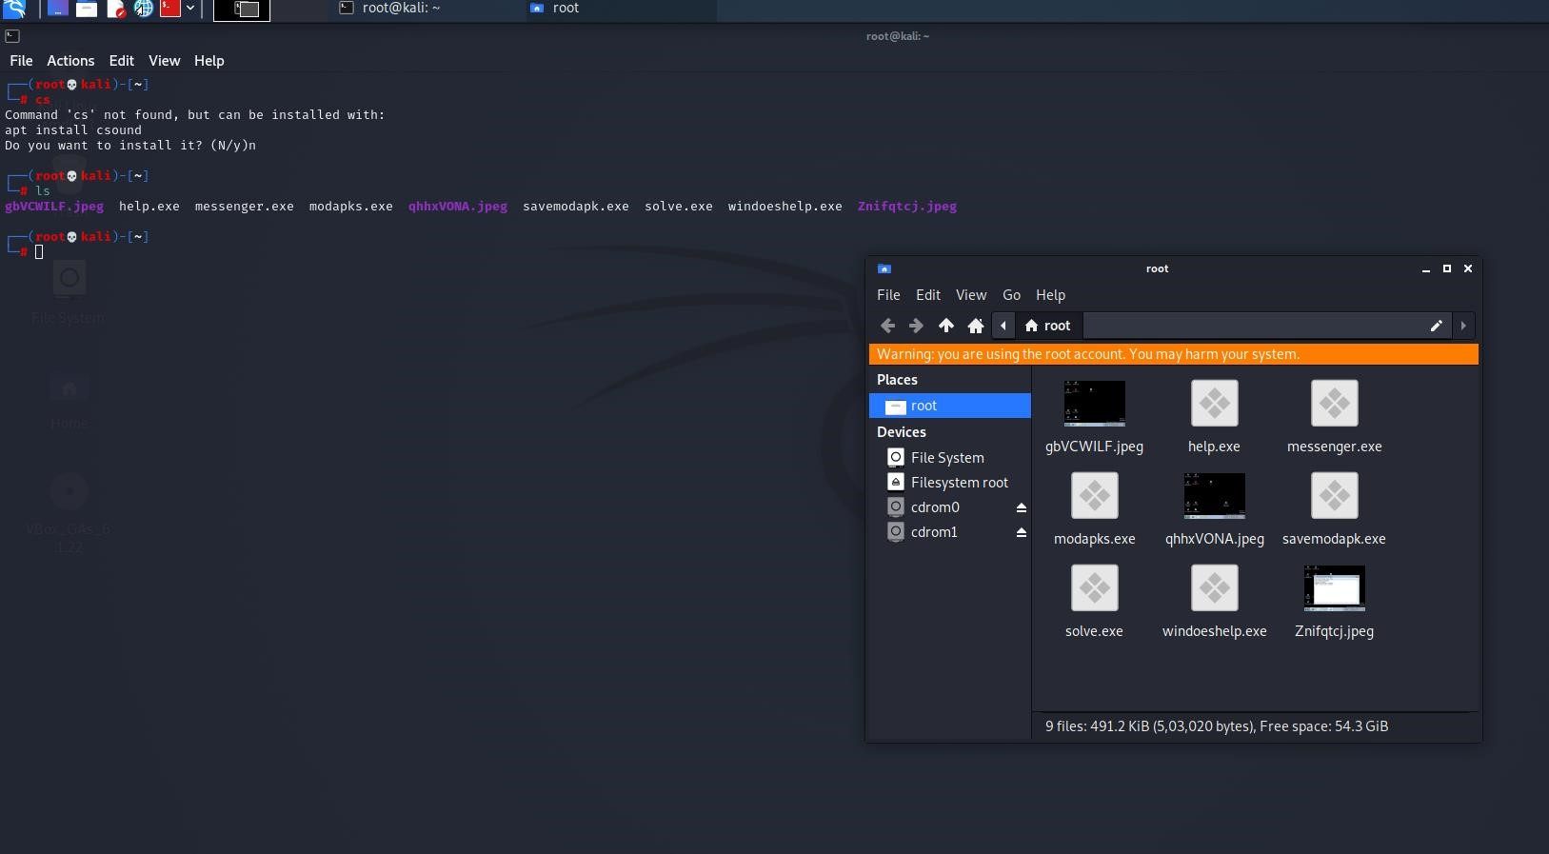

# Screen shots were saved in root directory of kali linux

**Conclusion:**

* Never click over unknown links or any links from unknown sources, as the current real world attacks are more powefull than above simulated test.
* Never download any application or module,etc from third party websites or unsecured websites.
* Keep browser and system security and anti-viurs updated and use browsers that provide well and optimum security
* Never turn off or lower the browser settings as the virus file can easily get downloaded without getting detected.
* Never turn off system security services like anti-virus and firewalls
* Perform security scan of entire system atleast 4 thrice or more in a month
* Don’t give permissions to applications which they don’t require and still ask for the permission, for example a drawing application named paint asks access location permission and contacts permission.

**Use SET Tool and create a fake Gmail page and try to capture the credentials in command line**

**Hacker Machine: Kali linux**

**Victim machine: Windows 10**

*First install SET Tool kit in your kali linux machine

*After installing the SET Tool kit, open it in your terminal

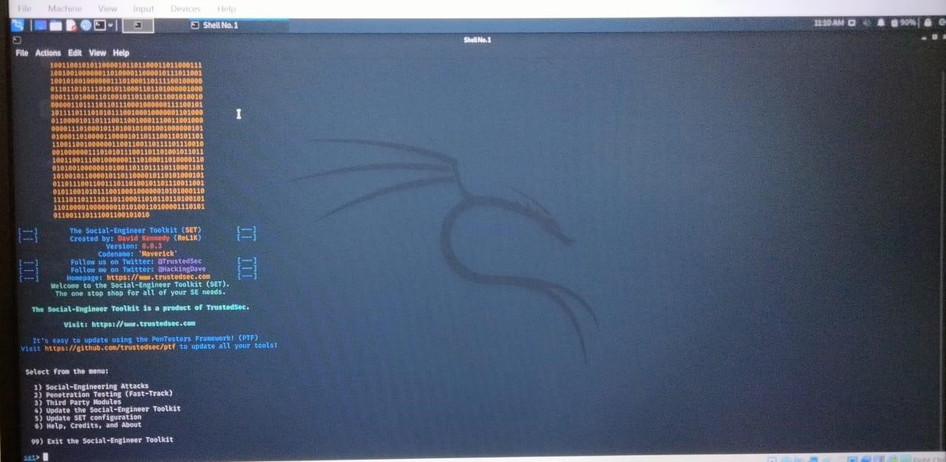

*Now select option 1 that is Social engineering attacks

*After selecting option 1 we will get

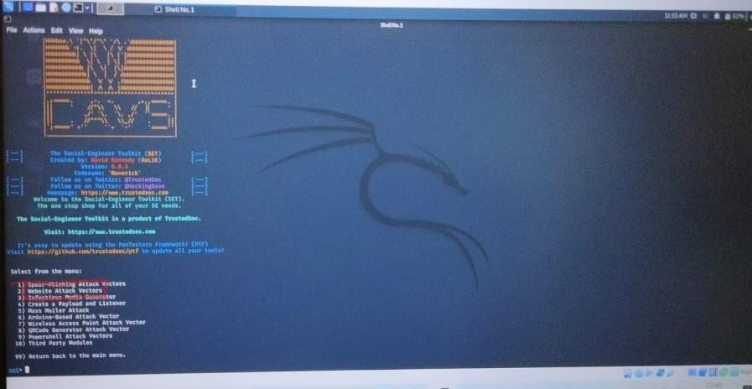

*Now we choose option 2 that is website attack vectors, Since we are attacking a website.

*After choosing Website attack vector

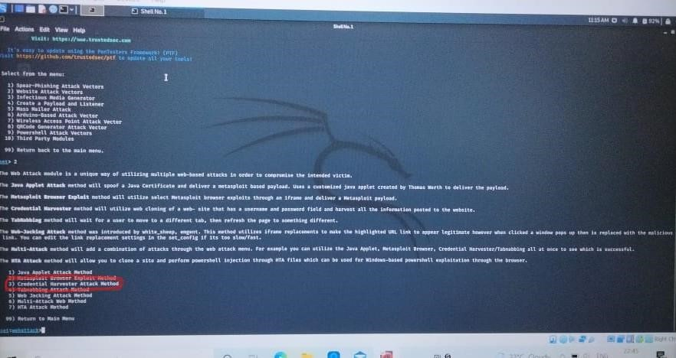

*Here we are choosing credential harvester attack method, since we have to capture the user credentials.

*After choosing this we will get

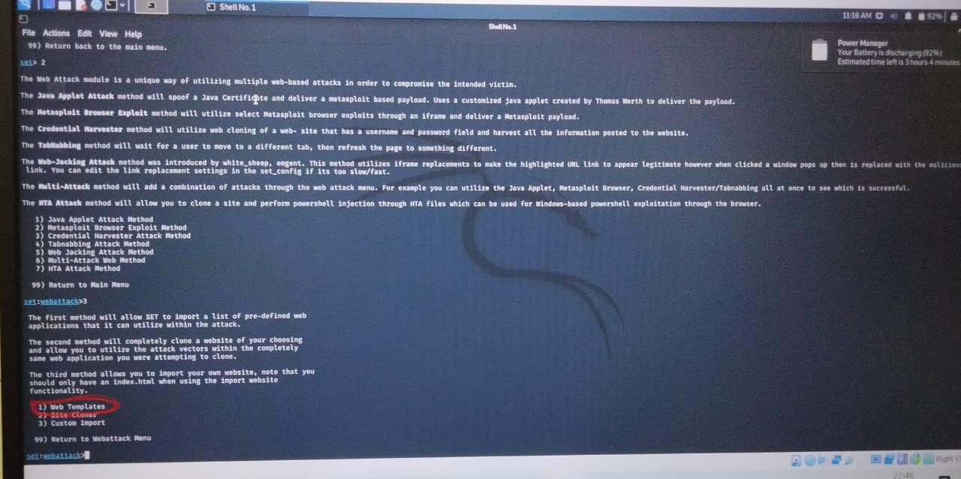

*Now choose web templates and continue further.

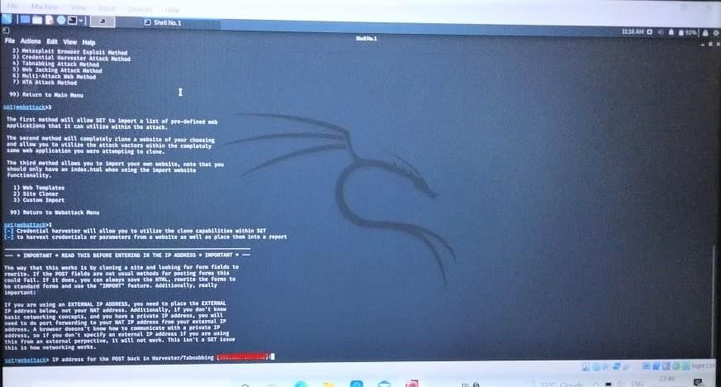

Here after choosing web templates it will display the IP address of the machine, where the credentials will be stored.

*Now we have to choose the templates

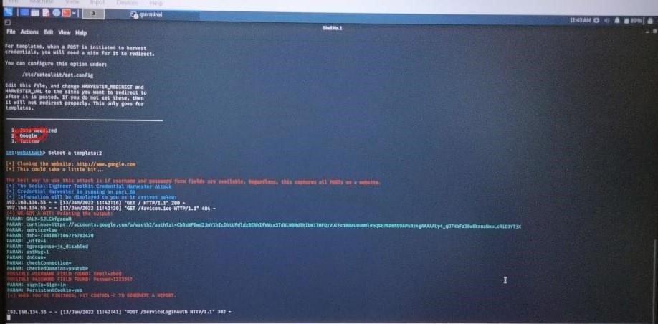

Now the fake login page is created, If we enter user id and password it will be stored here.

But in real world users do not believe in these type of links, so we have to create a fake g-mail page saying that

“we are from google and there is some problem in your g-mail account so please change your google password” and provide the link below.

*Now to send a mail to the target we will again use the SET Tool kit.

*After opening SET Tool kit in your terminal choose social engineering attacks.

*After that

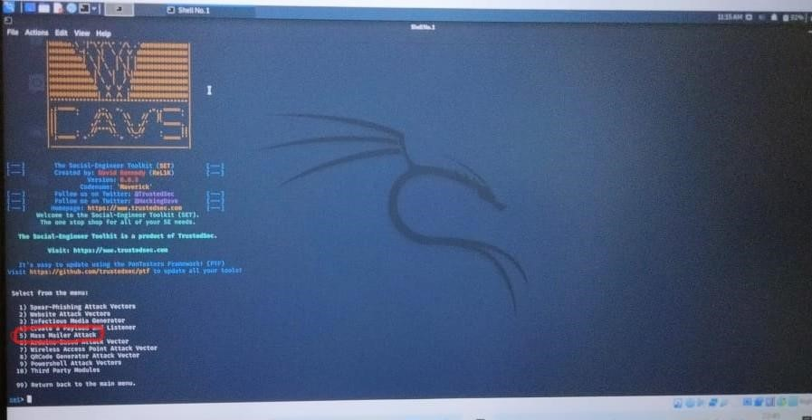

Choose mass mailer attack that’s option 5, since we have to send mail to the target.

After choosing mass mailer attacks

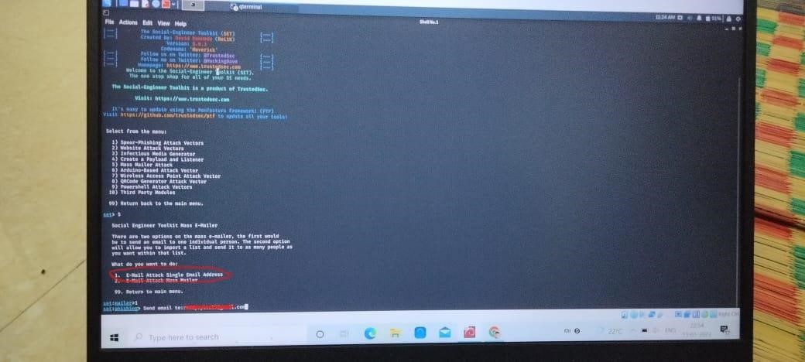

*Here we have to choose email attack to single email address.

*Enter the email address of the target.

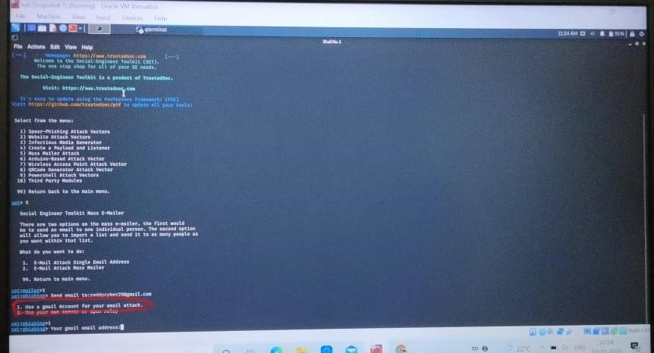

Choose the mail account and create a body of the mail saying that “some problem in the targets account”

And make target to enter the credentials through the link you provided.

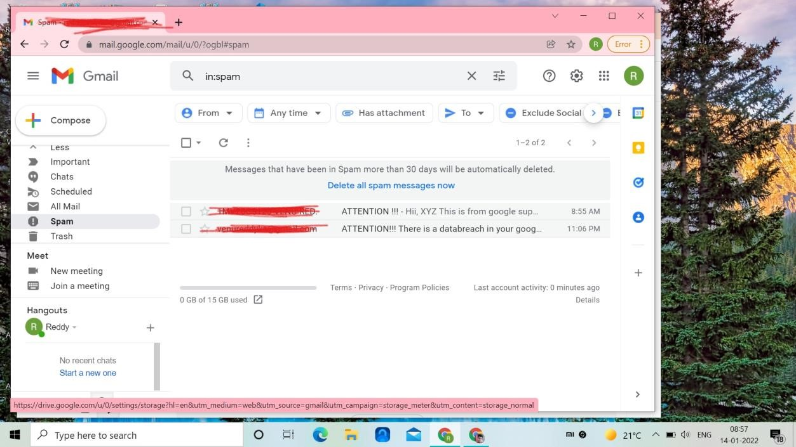

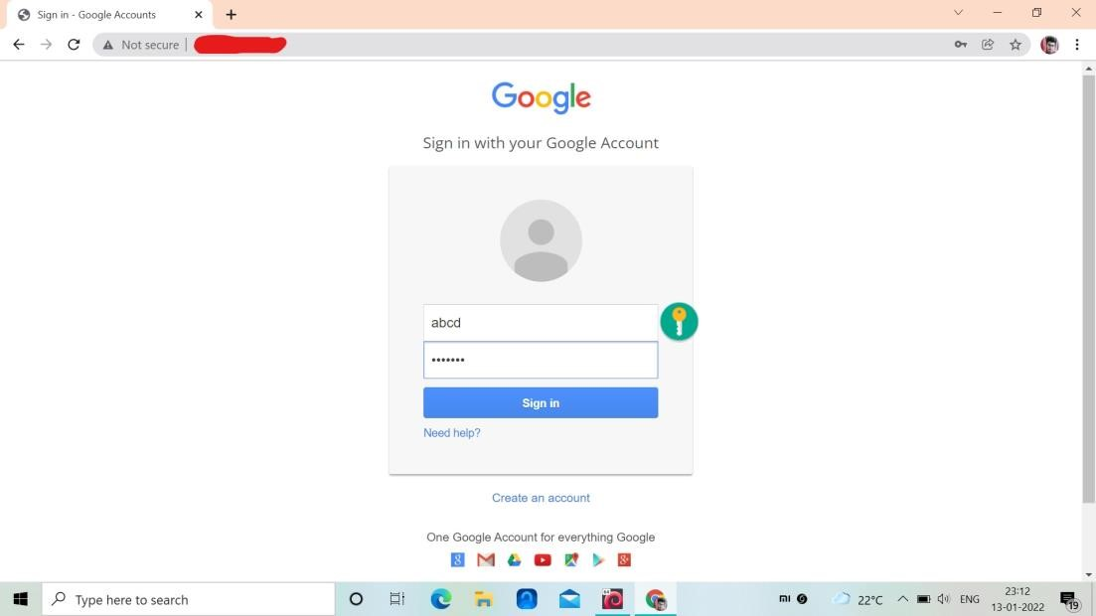

*After opening the link provided in the mail, it will be directed to this login page, were target need to enter his id and password.

*The entered user id and password will be captured in command line.

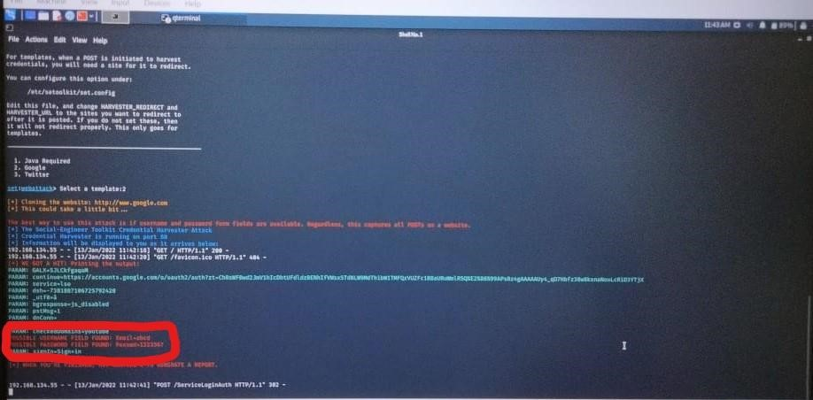

PREVENTION:

*Do not click on unknown links.

*Have anti vires installed in your system, so that it wont allow you to enter those type of pages.

*These type of messages will mostly found in spam, so be aware of spam messages.

*If you are not sure about the login page first enter wrong id and passwords, so that it will display that your user id is wrong. Then its original page.

*Do compare the mail you got with original google mail.

**Sql injection:**

Target: http://testphp.vulnweb.com

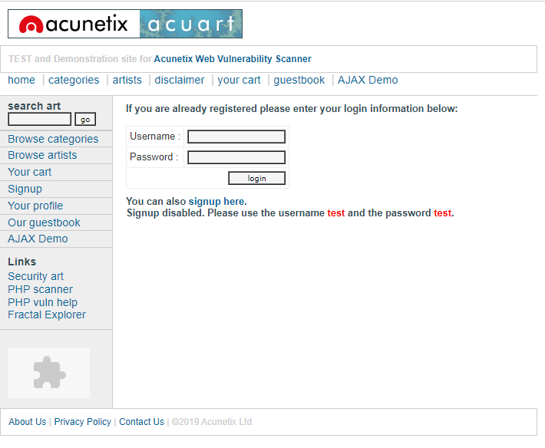

I first went to browse categories on the websites and clicked on posters to find the error in the url.

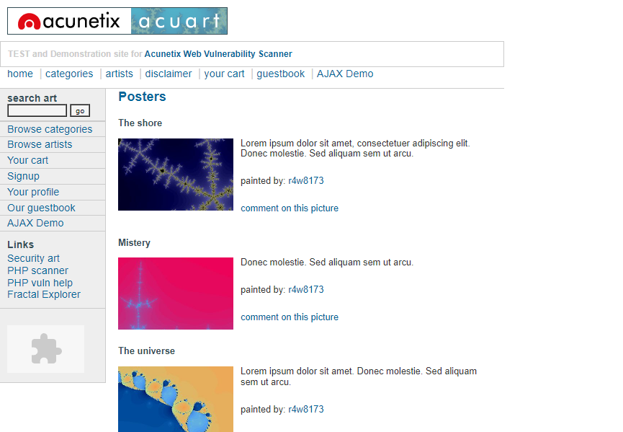

First I tried to add a special character (‘) in the url but it gave error.

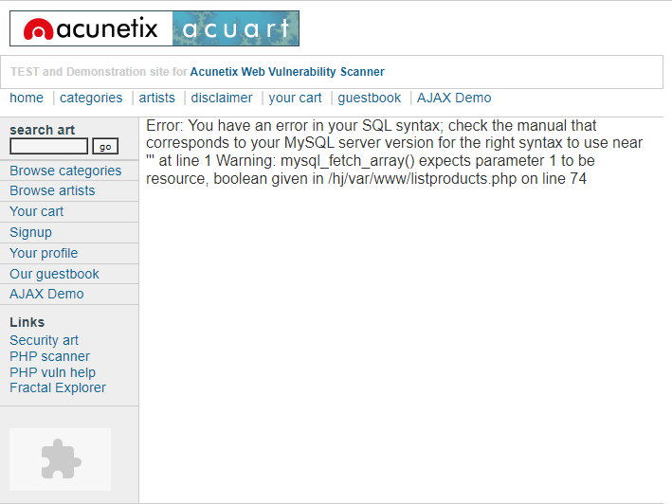

Then I added the command order by in the url with different numbers like 12,15,16,20 but all of them gave error except 11 which means 11 columns are available in public.

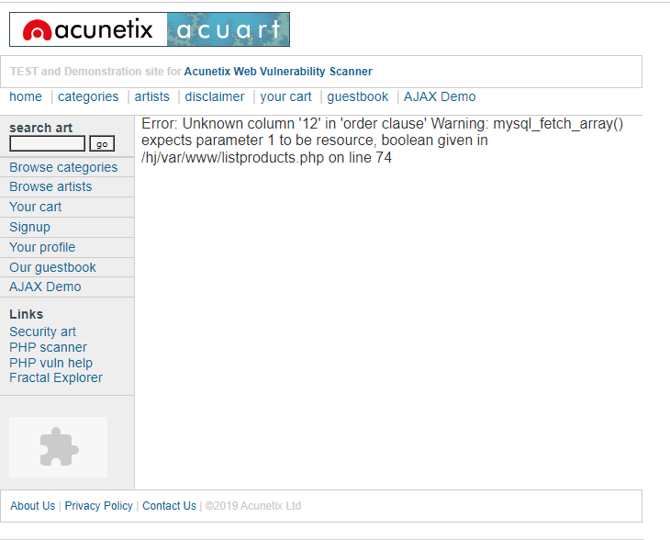

Then I executed the command union select 1,2,3,4,5,6,7,8,9,10,11 in the url . It gave me an extra column at the last with the numbers 7,2 and 9 which means the columns 7,2 and 9 are vulnerable.

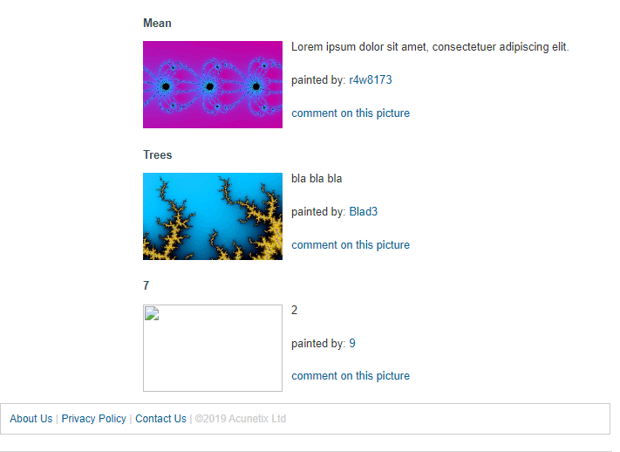

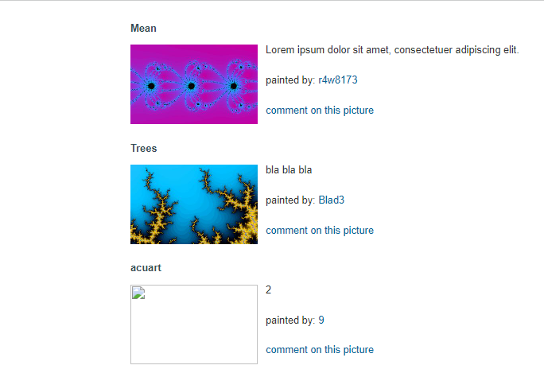Then to know the database name I replaced 7 with the command database() in the url.

I got the database name as acuart.

Then I replaced 7 with group_concat(table_name) and added from information_schema.tables where table_schema=database(). After exceuting this command we got the table names as artists,carts,carteg,featured,guestbook,pictures,products,users.

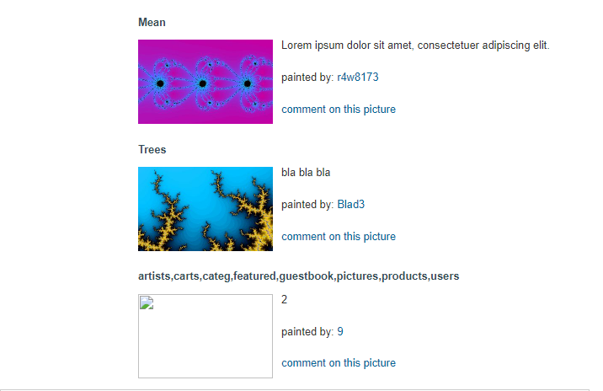

Then I changed table to columns in the url except the last part where i added table_name=0x7573657273 . By executing this command I got the column names of the users table which are address,cart,cc,email,name,pass,phone,uname.

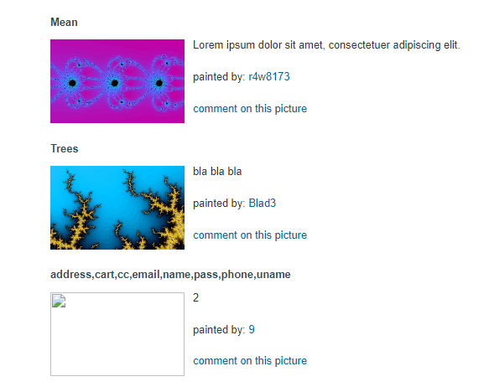

Then I replaced 7 by group_concat(uname,pass,email) in the url and added from users at the end of url.

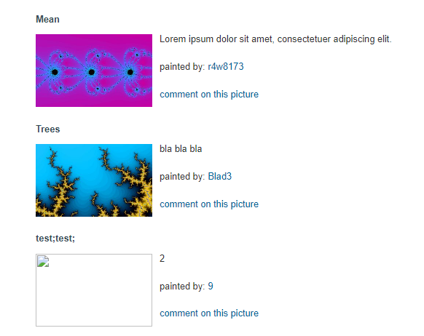

I finally got the username and password as test. I tried to enter the credentials in the website and it worked . This ends our sql injection process.

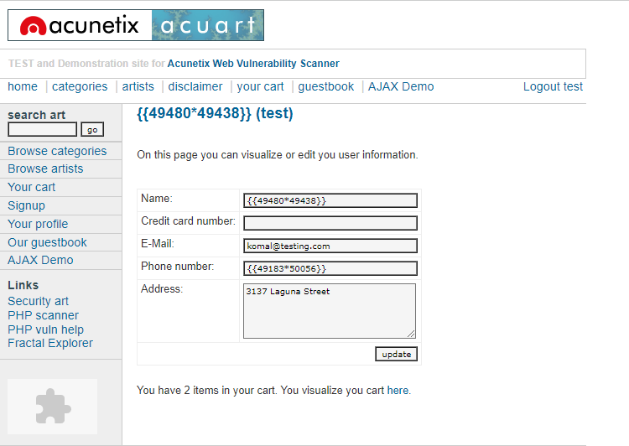

Threat : if this sql injection was performed by black hat hacker he could have easily used these credentials for the wrong purpose and the website might have been compromised. . All in all , no client’s credentials should be accessible to any unknown person which could compromise the privacy of the client as well as the website.

Solution :

The database admin should make sure that the sql commands are not accepted by the users. The network admin should secure the firewall. They may also hire a cybersecurity analyst to fully secure the website.

**Use Mobile tracker free (online tool) to install in android mobile phone and try to execute the commands and taken live webcam stream and screenshots and whatsapp messages. Write a report on the attack and provide solutions to avoid android hacking.**

Go to browser and search for mobile tracker free(online tool)

* First register into the app using your mail id

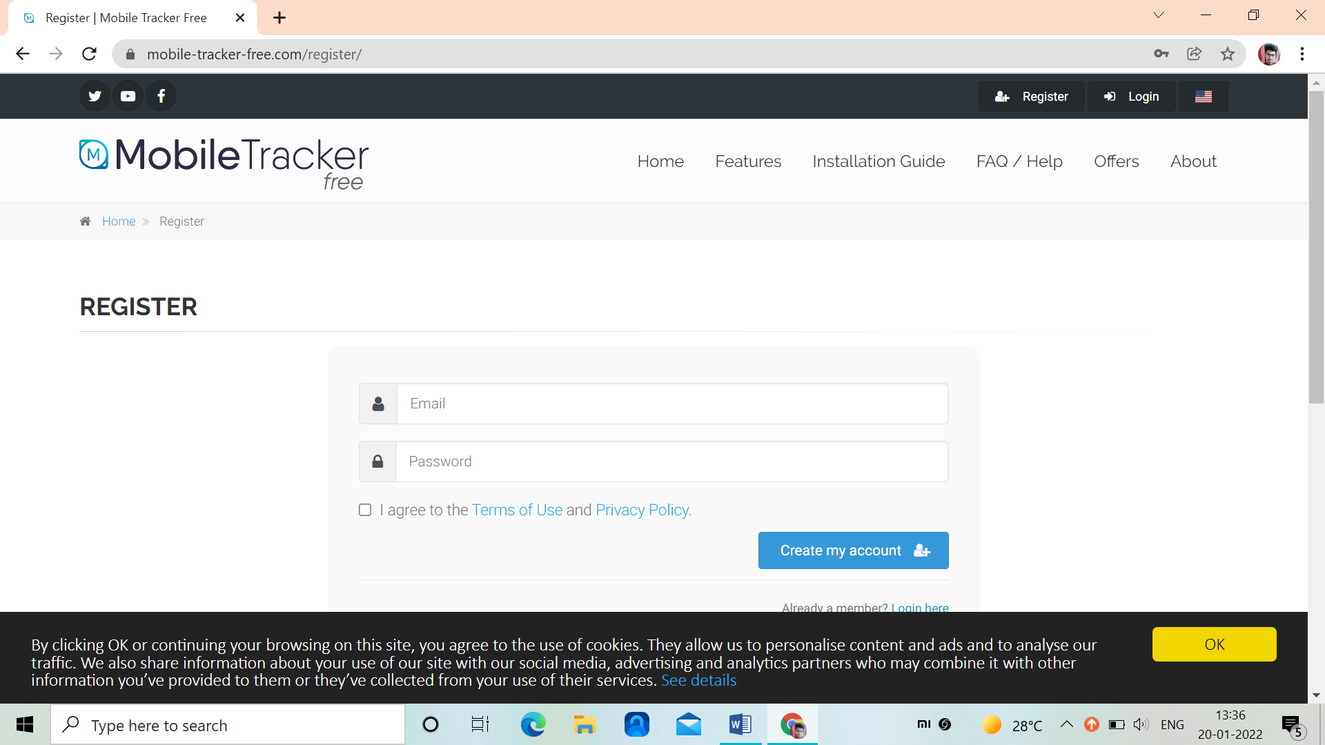

* Enter the email id and your password and create your account
* After creating you will have to confirm it via link sent to your mail

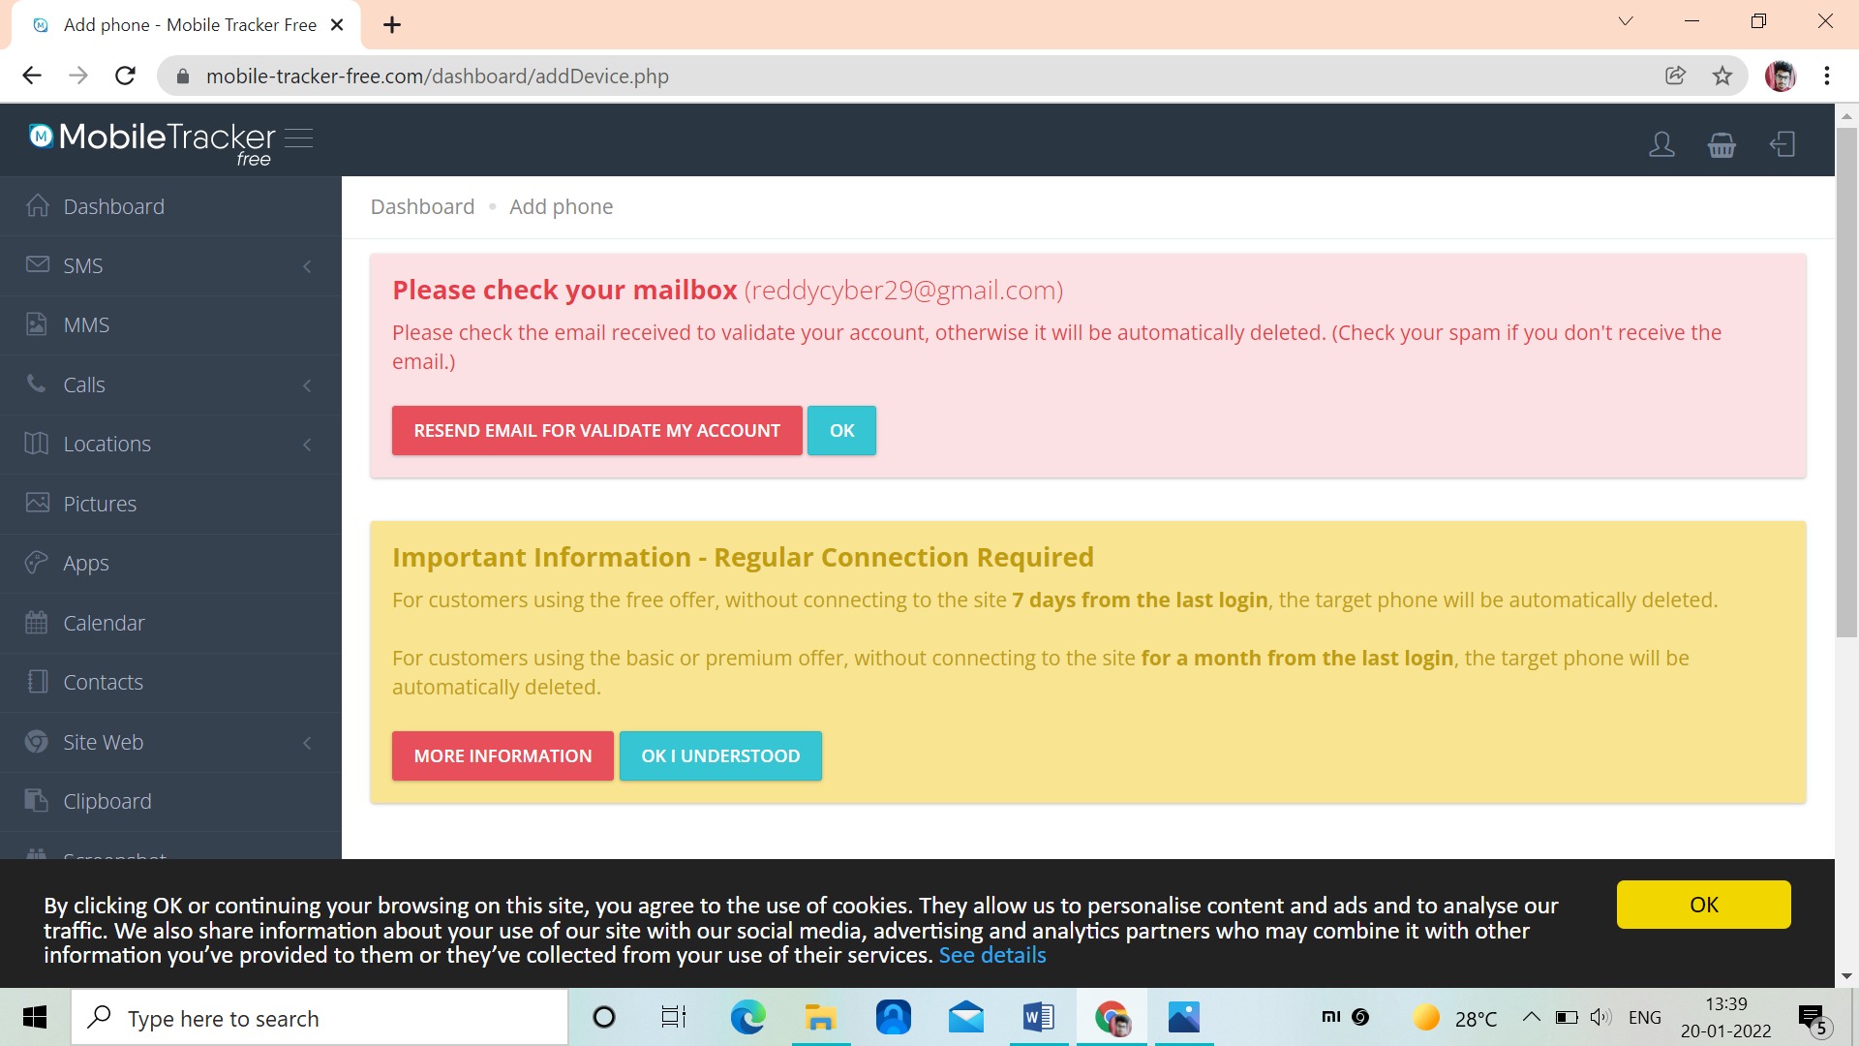

* After confirming the mail you received account will be created
* Now we have to link a device that we want to access
* Open the browser in the target phone, search for mobile tracker online
* Login into with your mail id given and its password
* You have accept some terms and conditions for installation
* After accepting terms and conditions, you have make some settings to access the device

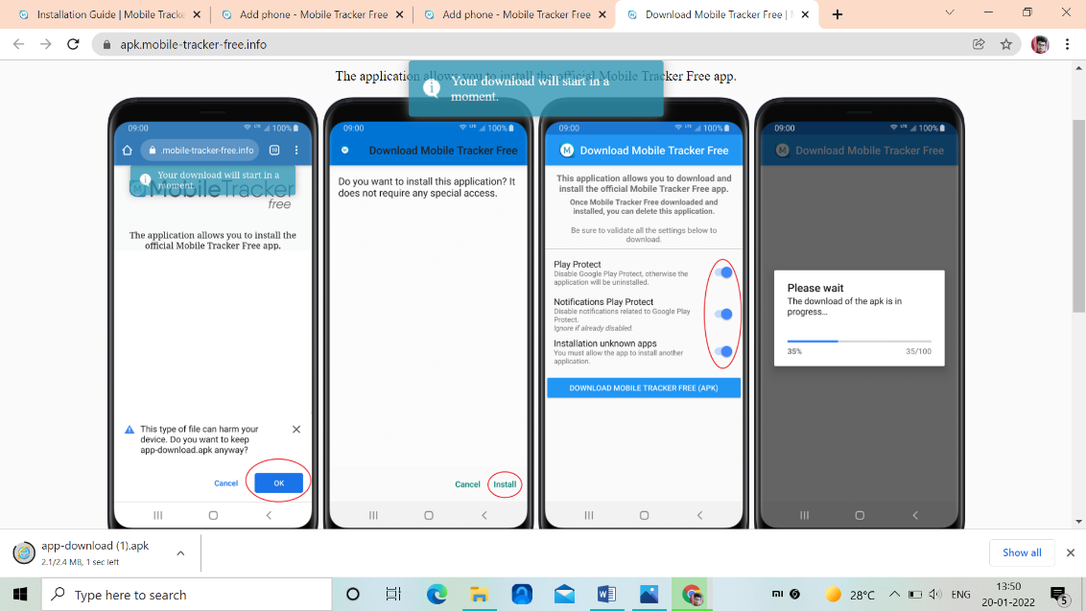

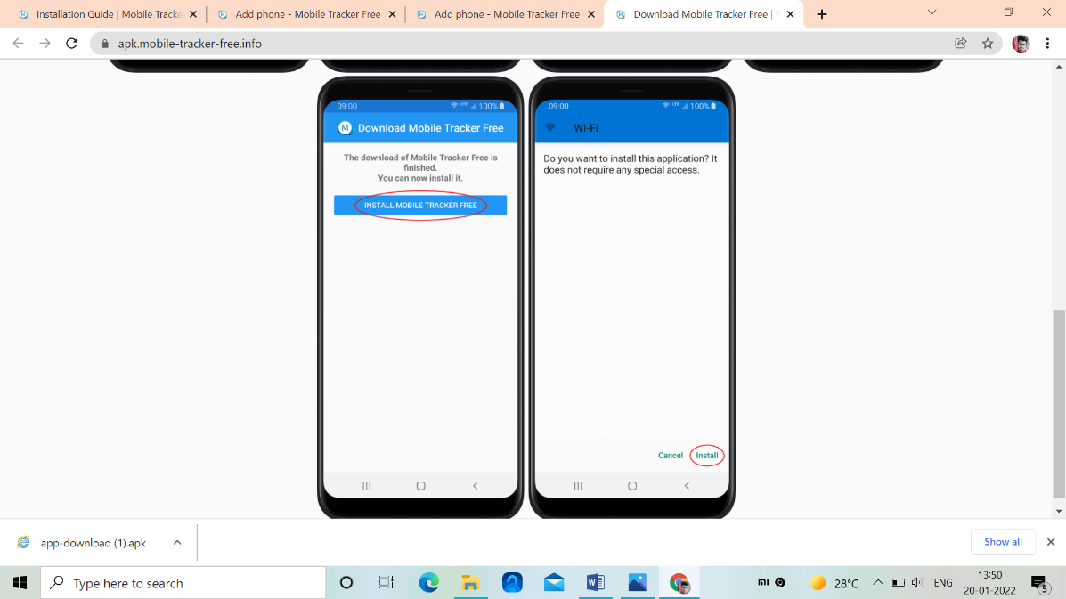

* Enable all these settings and install in targets device
* Now after installing we can access the target device from any device by knowing the mail id and password
* We can even take the screenshots of the android device

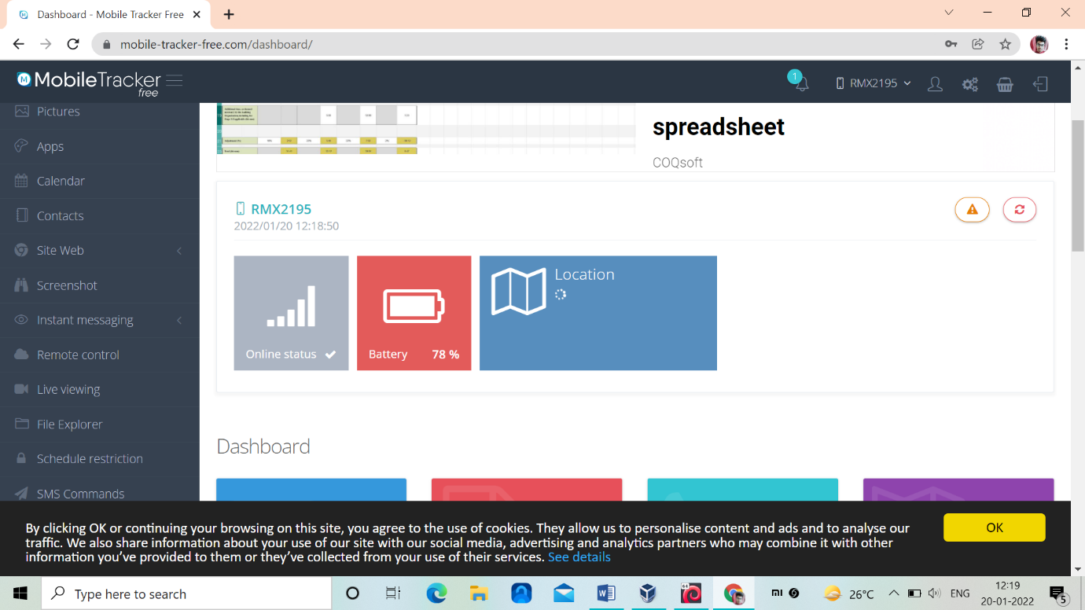

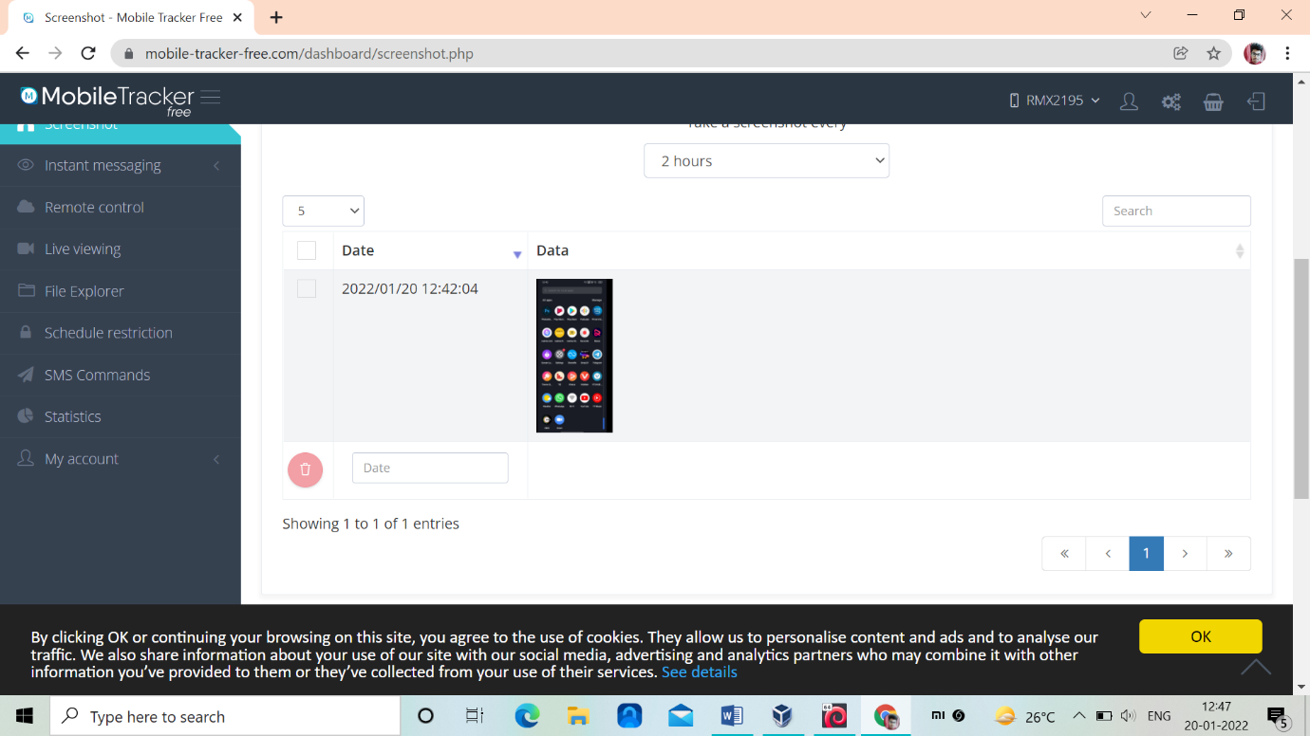

* We can even access into targets whatsapp and look into their documents, texts, images etc..,,,

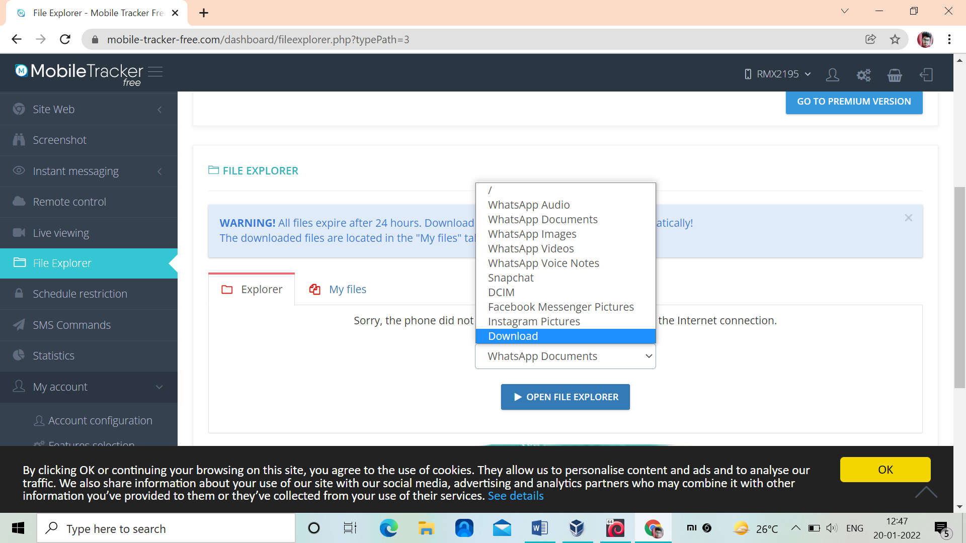

**Safety measures:**

* Do not give your phone to others, so they can install these type of apps in your device without knowing you
* Do confirm your mails twice, before you click on the links
* Check your settings, were you will have security, it contains admin devices, if such type of apps are present do remove those apps
* If you get to know about such account, do delete the accounts

**Write an Article on cybersecurity and recent attacks which you came across in media and research on the news and explain the any topic which you learned in this course and mention what you learned**

# Kaseya VSA ransomware attack

On 2 July 2021, a number of [managed service providers](https://en.wikipedia.org/wiki/Managed_service_provider) (MSPs) and their customers became victims of a [ransomware](https://en.wikipedia.org/wiki/Ransomware) attack perpetrated by the [REvil](https://en.wikipedia.org/wiki/REvil" \o "REvil) group, causing widespread downtime for over 1,000 companies

## **Company**

Kaseya Limited is an American software company founded in 2001. It develops software for managing [networks](https://en.wikipedia.org/wiki/Network_monitoring), [systems](https://en.wikipedia.org/wiki/System_monitor), and [information technology](https://en.wikipedia.org/wiki/Information_technology) infrastructure. Owned by [Insight Partners](https://en.wikipedia.org/wiki/Insight_Partners), Kaseya is headquartered in [Miami, Florida](https://en.wikipedia.org/wiki/Miami,_Florida) with branch locations across the US, Europe, and Asia Pacific.Since its founding in 2000, it has acquired 13 companies, which have in most cases continued to operate as their own brands (under the "a Kaseya company" tagline), including [Unitrends](https://en.wikipedia.org/wiki/Unitrends).

## **Timeline and impact**

The source of the outbreak was identified within hours to be VSA (Virtual System Administrator), a [Remote monitoring and management](https://en.wikipedia.org/wiki/Remote_monitoring_and_management) software package developed by Kaseya. An authentication bypass [vulnerability](https://en.wikipedia.org/wiki/Vulnerability_(computing)) in the software allowed attackers to compromise VSA and distribute a malicious payload through hosts managed by the software, amplifying the reach of the attack.In response, the company shut down its VSA [cloud](https://en.wikipedia.org/wiki/Cloud_computing) and [SaaS](https://en.wikipedia.org/wiki/Software_as_a_service) servers and issued a security advisory to any customers, including those with [on-premises](https://en.wikipedia.org/wiki/On-premises_software) deployments of VSA.

Initial reports of companies affected by the incident include Norwegian financial software developer [Visma](https://en.wikipedia.org/wiki/Visma" \o "Visma), who manages some systems for Swedish supermarket chain [Coop](https://en.wikipedia.org/wiki/Kooperativa_F%C3%B6rbundet). The supermarket chain had to close down its 800 stores for almost a week, some in small villages without any other food shop. They did not pay ransom, but rebuilt their systems from scratch after waiting for an update from Kaseya.

The [REvil](https://en.wikipedia.org/wiki/REvil" \o "REvil) ransomware gang officially took credit for the attack and claimed to have encrypted more than one million systems during the incident. They initially asked for a $70 million ransom payment to release a universal decryptor to unlock all affected systems. On July 5, Kaseya said that between 800 and 1,500 downstream businesses were impacted in the attack

[Marcus Hutchins](https://en.wikipedia.org/wiki/Marcus_Hutchins) criticized the assessment that the impact of the Kaseya attack was larger than [WannaCry](https://en.wikipedia.org/wiki/WannaCry_ransomware_attack" \o "WannaCry ransomware attack), citing difficulties in measuring the exact impact.

After a 9 July 2021 phone call between United States president [Joe Biden](https://en.wikipedia.org/wiki/Joe_Biden) and Russian president [Vladimir Putin](https://en.wikipedia.org/wiki/Vladimir_Putin), Biden told the press, "I made it very clear to him that the United States expects when a ransomware operation is coming from his soil even though it’s not sponsored by the state, we expect them to act if we give them enough information to act on who that is." Biden later added that the United States would take the group's servers down if Putin did not.

On 13 July 2021, REvil websites and other infrastructure vanished from the internet.

On 23 July 2021, Kaseya announced it had received a universal decryptor tool for the REvil-encrypted files from an unnamed "trusted third party" and was helping victims restore their files

On 8 November 2021, the [United States Department of Justice](https://en.wikipedia.org/wiki/United_States_Department_of_Justice) unsealed indictments against Ukrainian national Yaroslav Vasinskyi and Russian national Yevgeniy Polyanin. Vasinskyi was charged with conducting ransomware attacks against multiple victims including Kaseya, and was arrested in Poland on 8 October. Polyanin was charged with conducting ransomware attacks against multiple victims including Texas businesses and government entities. The Department worked with the [National Police of Ukraine](https://en.wikipedia.org/wiki/National_Police_of_Ukraine) for the charges, and also announced the seizure of $6.1 million tied to ransomware payments. If convicted on all charges, Vasinskyi faces a maximum penalty of 115 years in prison, and Polyanin 145 years in prison.

**Use Wireshark tool to identify the traffic inspect and see the content flowing in website while you are accessing any http website to login.**

About wireshark:

* Wireshark is a free and open source network protocol analyzer that enables users to interactively browse the data traffic on a computer network. The development project was started under the name Ethereal, but was renamed Wireshark in 2006.
* Many networking developers from all around the world have contributed to this project with network analysis, troubleshooting, software development and communication protocols. Wireshark is used in many educational institutions and other industrial sectors.
* Wireshark is a network or protocol analyzer (also known as a network sniffer) available for free at the Wireshark website. It is used to analyze the structure of different network protocols and has the ability to demonstrate encapsulation.
* The analyzer operates on Unix, Linux and Microsoft Windows operating systems, and employs the GTK+ widget toolkit and pcap for packet capturing.
* Wireshark and other terminal-based free software versions like Tshark are released under the GNU General Public License.
* Wireshark shares many characteristics with tcpdump. The difference is that it supports a graphical user interface (GUI) and has information filtering features. In addition, Wireshark permits the user to see all the traffic being passed over the network.

Features of Wireshark

* Data is analyzed either from the wire over the network connection or from data files that have already captured data packets.
* Supports live data reading and analysis for a wide range of networks (including Ethernet, IEEE 802.11, point-to-point Protocol (PPP) and loopback).
* With the help of GUI or other versions, users can browse captured data networks.
* For programmatically editing and converting the captured files to the editcap application, users can use command line switches.
* Display filters are used to filter and organize the data display.
* New protocols can be scrutinized by creating plug-ins.
* Captured traffic can also trace Voice over Internet (VoIP) calls over the network.
* When using Linux, it is also possible to capture raw USB

MAIN FEATURES OF WIRESHARK

* **Packet Capture:** Wireshark listens to a network connection in real time and then grabs entire streams of traffic – quite possibly tens of thousands of packets at a time.
* **Filtering:** Wireshark is capable of slicing and dicing all of this random live data using filters. By applying a filter, you can obtain just the information you need to see.
* **Visualization:** Wireshark, like any good packet sniffer, allows you to dive right into the very middle of a network packet. It also allows you to visualize entire conversations and network streams.

Users of network analyzers

* System administrators
* Understand system problems and performance
* Malicious individuals (intruders)
* Capture cleartext data
* Passively collect data on the following vulnerable protocols: FTP, POP3, IMAP, SMATP, rlogin, HTTP, and so on.
* Capture VoIP data
* Map the target network
* Discover traffic patterns
* Actively break into the network (backdoor techniques)

Different protocols

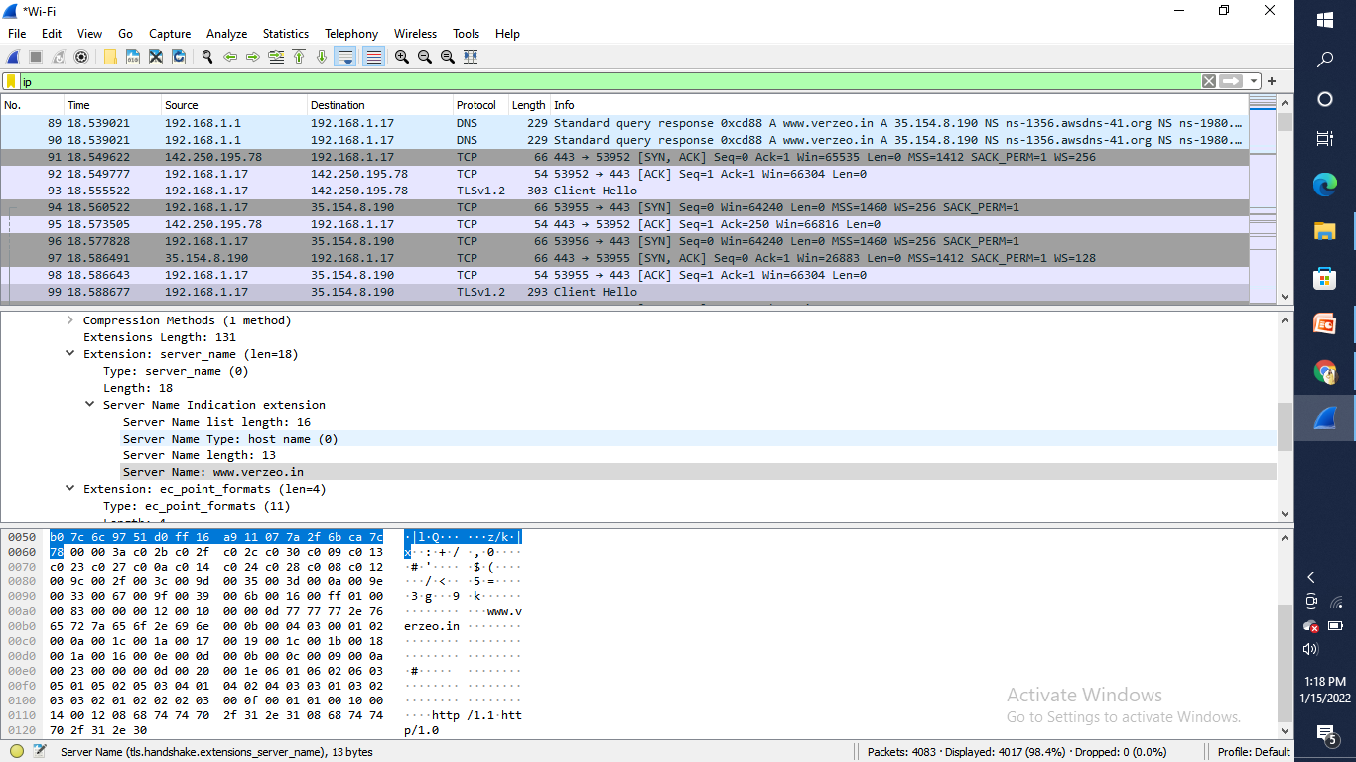

UDP

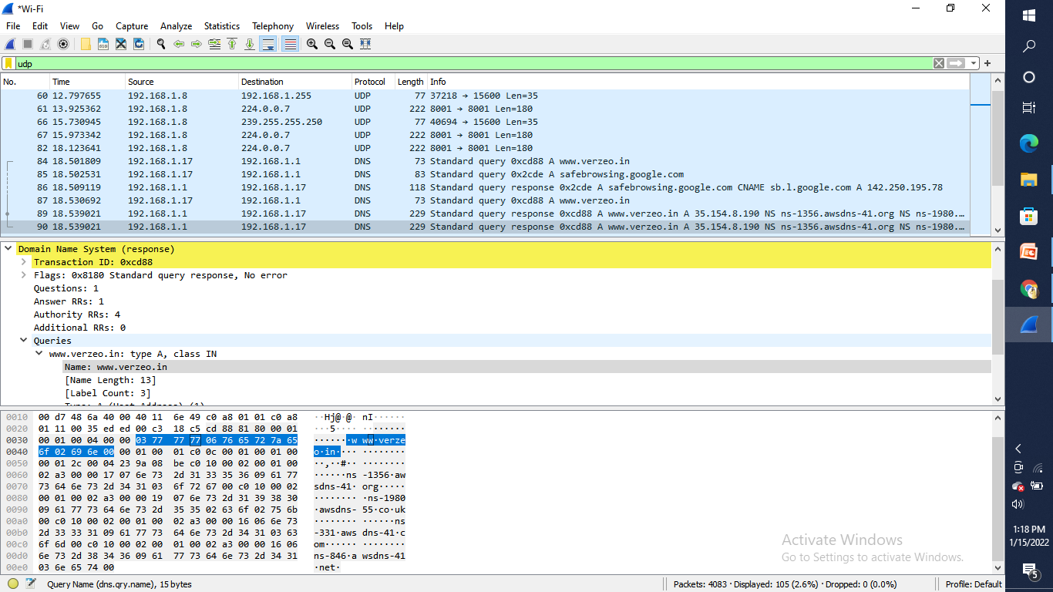

TCP

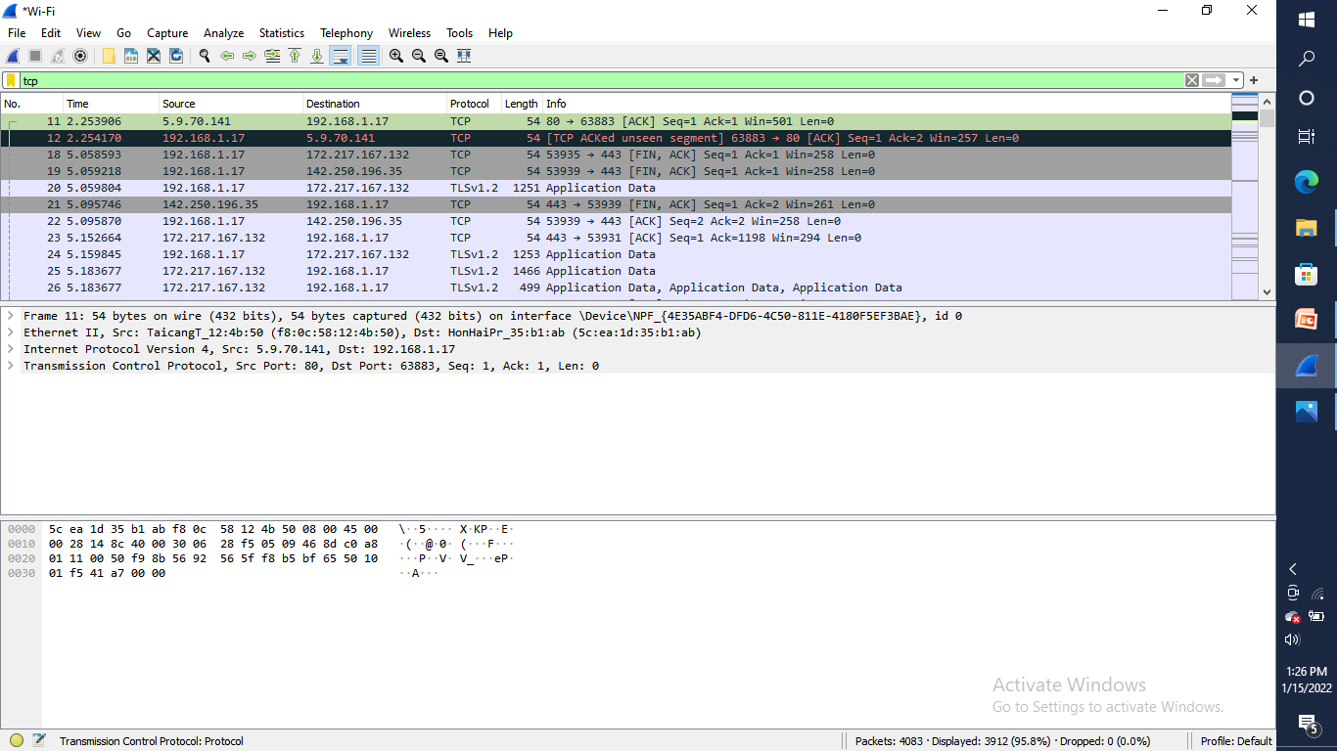

Traffic while accessing website can be find giving filter tcp port ==80

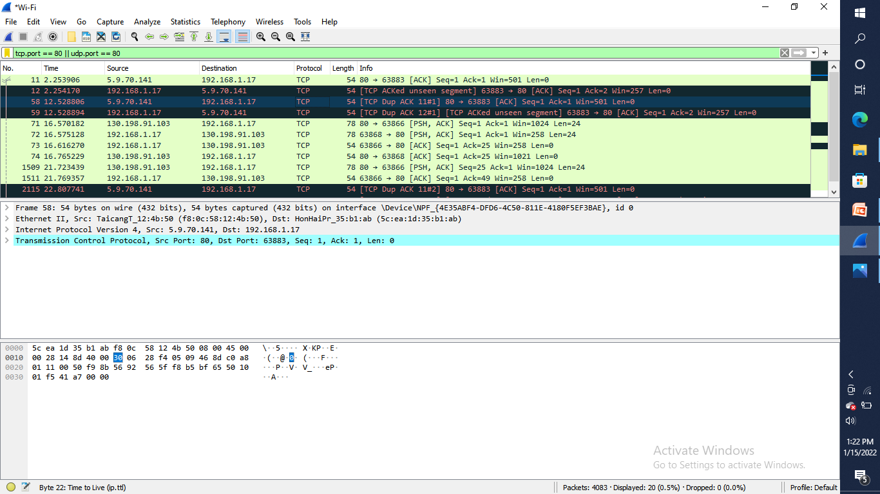

Acuart is an unsecure website if we type an password while packet sniffing scan is running in wireshark , it can find password

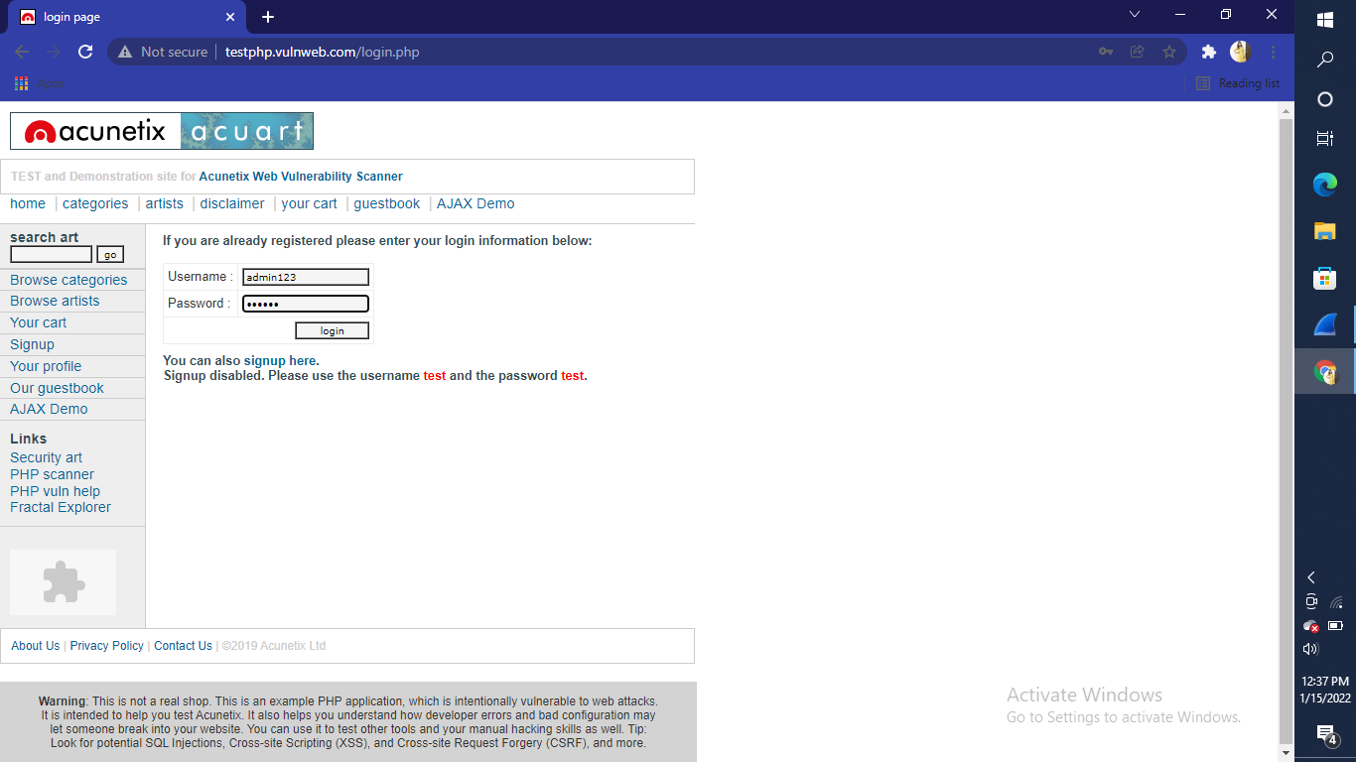

By typing my username in filter box it is giving password of acuart website

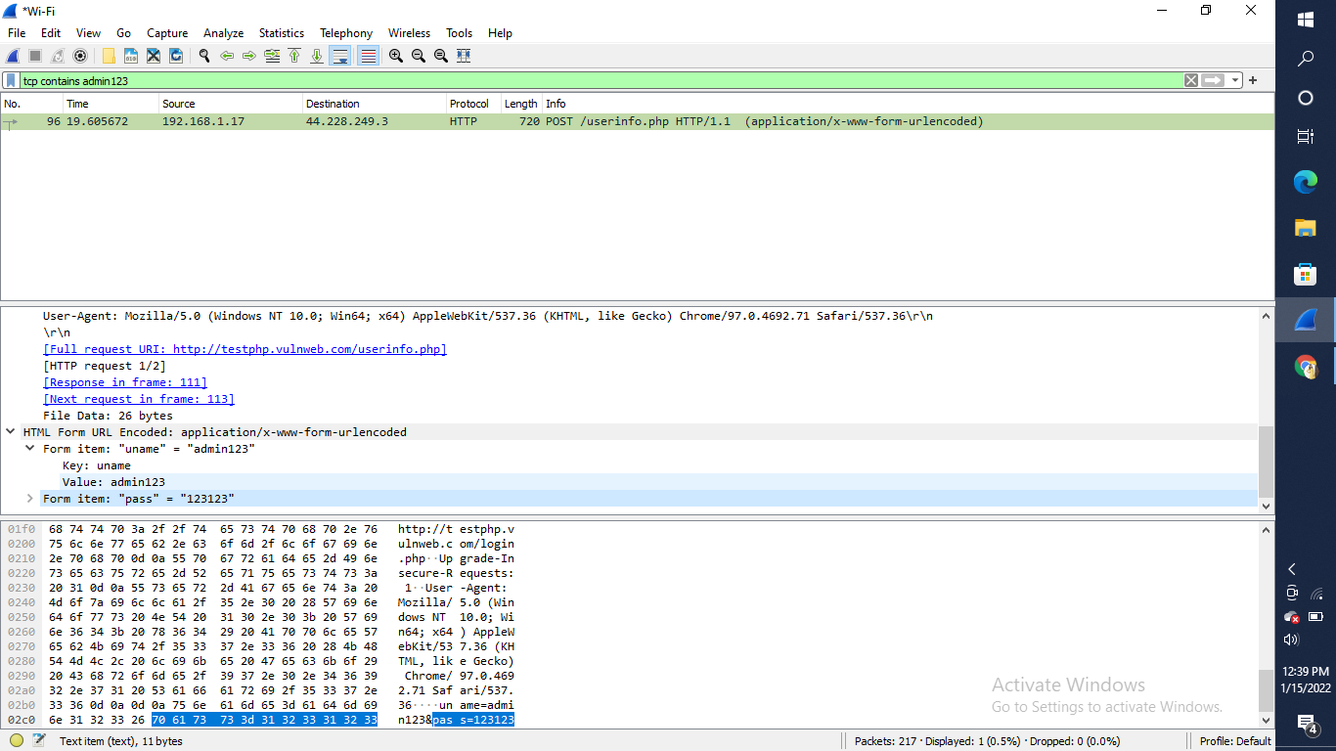

Wireshark i/o graph will show the overall traffic seen in a capture file where X axis shows time(s) and Y axis is packet/1sec

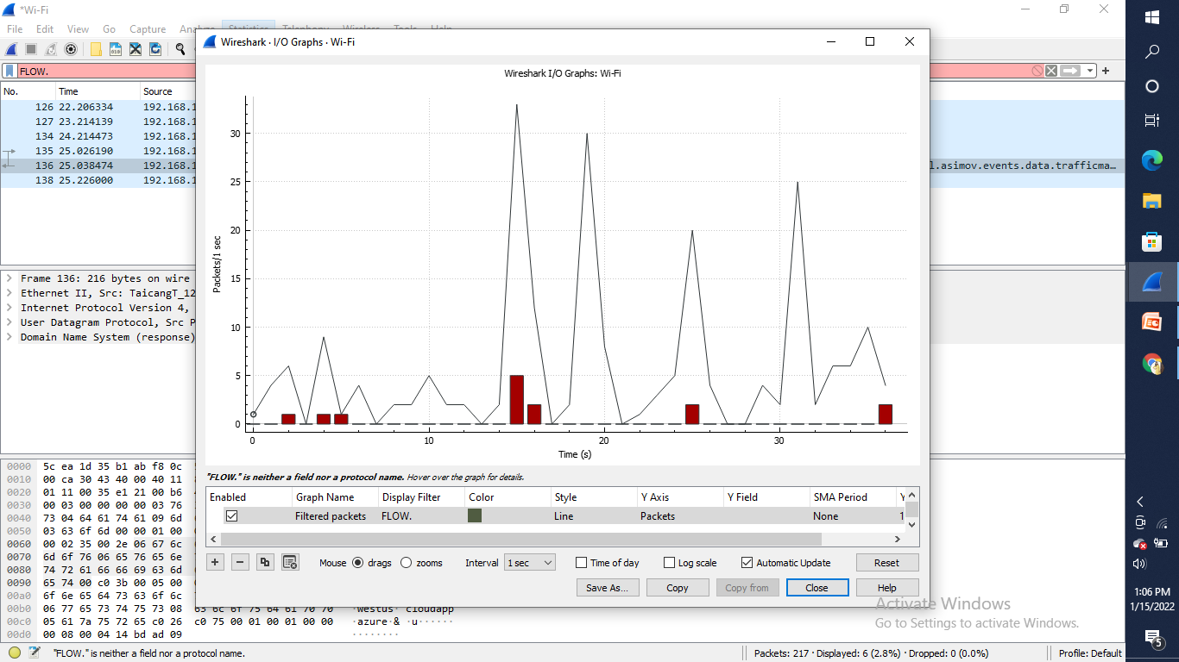

Content flowing while accessing verzeo website filter used for content is tcp contains verzeo

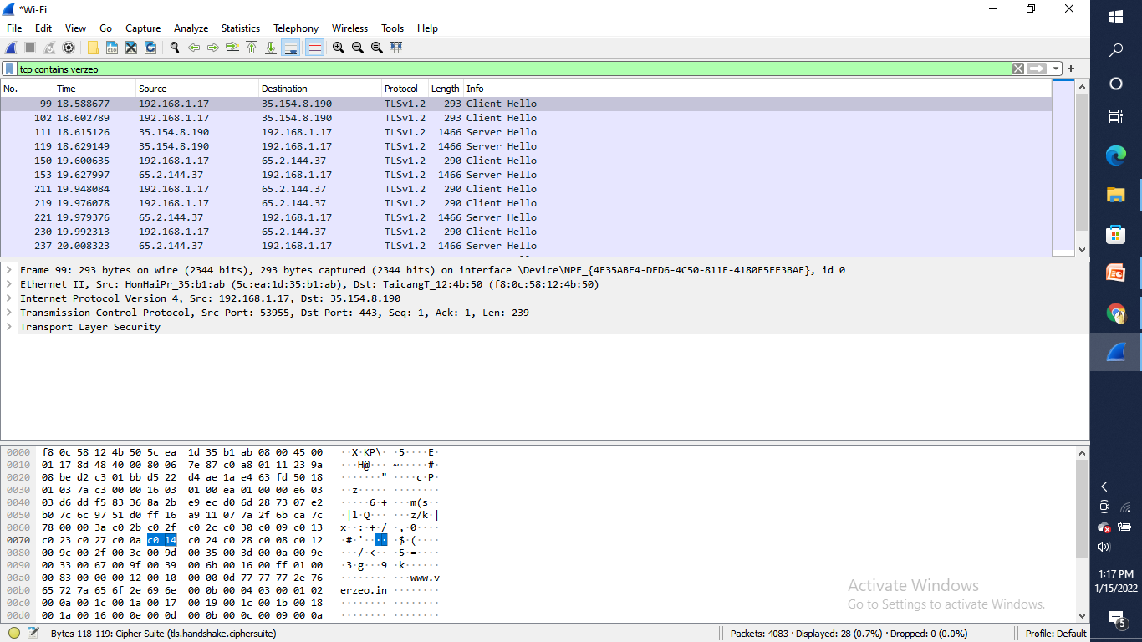

It is showing that Godaddy ,which is hosting the website

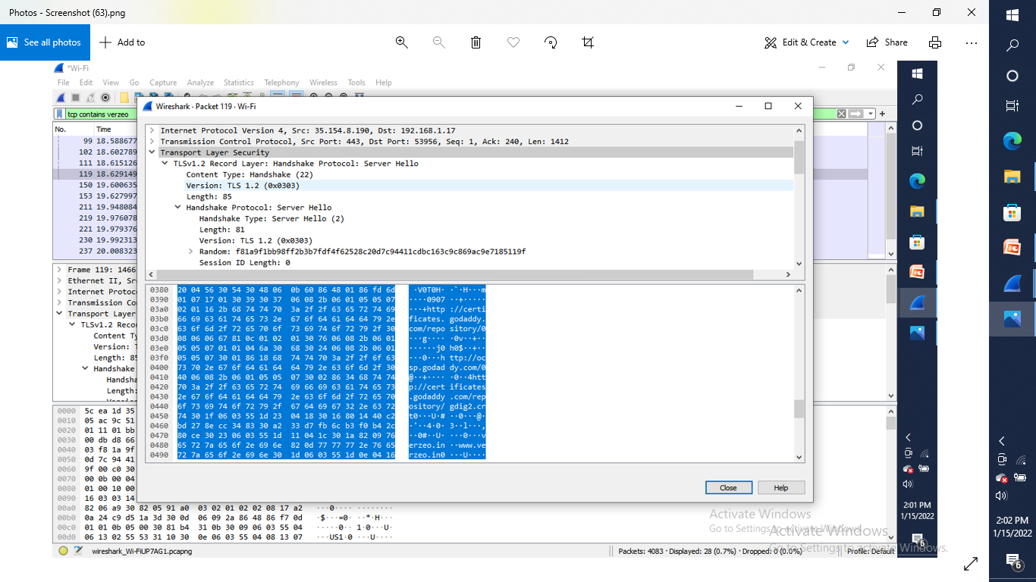

How to defend against sniffing

* Restrict the physical access to the network media to ensure that a packet sniffer cannot be installed.
* Use encryption to protect confidential information.
* Permanently add the MAC address of the gateway to the ARP cache.
* Use static IP addresses and static ARP tables to prevent attackers from adding spoofed ARP entries for their machines to the network.
* Turn off network identification broadcasts, and if possible, restrict the network to authorized users in order to protect the network from being discovered with sniffing tools.
* Use the IPv6 instead of the IPv4 protocol.
* Use encrypted sessions such as Secure Shell (ssh) instead of Telnet.
* Use Secure Copy (scp) instead of a file transfer protocol (ftp).
* Use Secure Socket Layer (SSL) for email connections.

Conclusion

* These days, many attacks happen through packet sniffing. Packet sniffers are placed in cyber cafes and on open wifi in restaurants, hotels, and public places. You can protect your data with a little caution.
* You should never use open wifi and should stop using open text protocols like ftp, http, IMAP, Telnet, and SNMP V1 and V2. You must install SSL certificates in your websites
* use Secure File Transfer Protocol (sftp) instead of ftp, and use SSH instead of telnet. You should use SNMP V3 and opt for encryption.